 | Literacy/  Numeracy  Time  9:00 – 9:30 | Lesson 1  9:30 – 10:20 | Break  7SA Timetable 2025-2026  10:20 -10:35 | Lesson 2  10:35 – 11:30 | Lesson 3  11:30 – 12:20 | Lunch  12:20 – 12:55 | Lesson 4  12:55 – 1:20 | Lesson 5  1:20 – 2:10 | Lesson 6  2:10 – 3:00
Monday |   Hall |   P4A  Room 1 |  |   P4A  Room 1 | P4A  Room 1 |  | 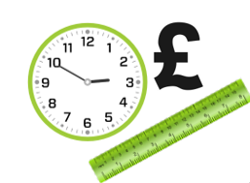    Numeracy |   WiderWorld | WiderWorld
Tuesday |   Guided reading | English  Room 1 |  |  Science  Room 1 |  Maths  Room 1 |  |   British Values/  Current affairs |   Creative Studies  Room 5 or PA | Creative Studies  Room 5 or PA
Wednesday |   Numeracy | 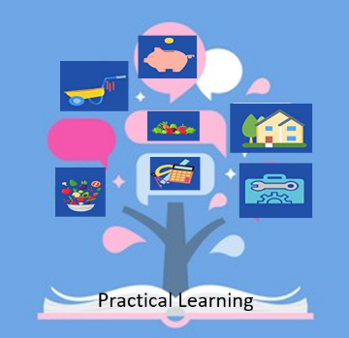  Practical learning R1 |  |   Practical learning R1 | Practical learning R1 |  |   Literacy | English  Room 1 |   Maths  Room 1
Thursday | Literacy |   ICT room |  |   Beliefs and Values |  English  Room 1 |  | Numeracy | Maths  Room 1 |   PE Hall
Friday |   Pastoral |   FT/DT |  | FT/DT |   PE Hall |  |   Pastoral  Credits | Science  Room 1 |   Reward Time  Room 1

