YEAR 7 |  | Spring
 | Rights of the Child | Article 29 (goals of education) Education must develop every child’s personality, talents and abilities to the full. It must encourage the child’s respect for human rights, as well as respect for their parents, their own and other cultures, and the environment.
 | English | The Boy at the Back of the Class by Onjali Q. Rauf
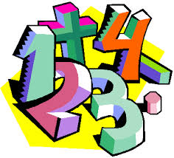 | Maths | 7LA Place value within 20 then 50  7SA Multiplication and division, Measures, Statistics, Length and Perimeter, Fractions.
 | Science | 7SA- Cells and Organisation, Atoms and the Periodic Table  7LA- Mixtures and separations
 | Computing/ICT | Scratch Programming, Desktop Publishing (Making a Leaflet)
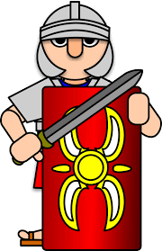 | The Wider World | The Norman Conquest  Settlements
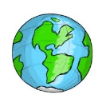 | Practical Learning | Gardening- Weeding/ Planting Seeds  Forest School- Woodcraft/Fire  Global Learning- Martin Luther King Day, Chinese New Year, Big Bird School Watch, Fairtrade Week, Shakespeare Week  Life Skills- First Aid: Bites and Stings, Asthma, Going to the Shop  Practical Numeracy- What is money?, Super smoothie shop, working out prices, giving change, How are payments changing,  Practical Literacy- Presentations, Speaking Listening, Turn taking, Instructions, Board games  Trips out- Library, Co-op
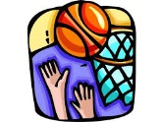 | P.E. | Health Related Fitness, Cricket, Rebound Therapy/Trampolining, Hockey
 | Design Tech | Ball bearing game  Health & Safety, Key fob
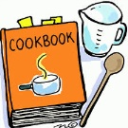 | Food Tech | Health & Safety, Fairtrade products, Festivals, Easter Cookery
 | Creative Studies | Art - Romans Mosaics  Music - Interpreting Music
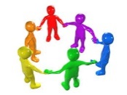 | PHSCE | 7SA & 7LA : Relationships - Diversity, prejudice and bullying including cyber bullying  Relationships - Self-esteem, romance and friendship  Careers - Introduction to Careers
 | RE | 7SA CHRISTIANITY – SIKHISM  7LA Christianity- Sikhism
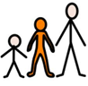 | Preparing for Adulthood | Relationships - Self-esteem, romance and friendship  Introduction to Careers - Raising awareness of the variety of jobs all around us  Housekeeping- Jobs around the home  Community Inclusion: Diversity, Prejudice and Bullying

