YEAR 11 |  | Autumn | Spring | Summer
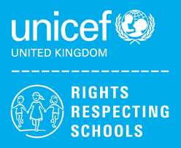 | Rights of the Child | Article 29 (goals of education) Education must develop every child’s personality, talents and abilities to the full. It must encourage the child’s respect for human rights, as well as respect for their parents, their own and other cultures, and the environment. | Article 29 (goals of education) Education must develop every child’s personality, talents and abilities to the full. It must encourage the child’s respect for human rights, as well as respect for their parents, their own and other cultures, and the environment. | Article 29 (goals of education) Education must develop every child’s personality, talents and abilities to the full. It must encourage the child’s respect for human rights, as well as respect for their parents, their own and other cultures, and the environment.
 | English | Paper 2 – Reading  Step Up to English – Component 1 – Speaking and Listening  Step Up to English – Component 1 - Reading | Paper 2 – Writing  Writing to present a viewpoint  Paper 1 – Revision  Step Up to English – Component 1 – Writing  Functional Skills English – Speaking & Listening  Presentation Skills | Paper 2 – Revision  Exam Skills and Preparation  Functional Skills English – Speaking & Listening  Discussions  Literacy for Life & the world of work
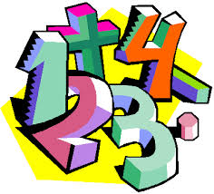 | Maths | Entry Level  Working with measures  Money  GCSE  Properties of polygons  Real life graphs  Probability  Volume  Algebra quadratics  Mock examinations (1)  Inequalities | Entry Level  Money  Working with whole numbers  GCSE  Algebra and graphs  Sketching graphs  Mock examinations (2)  Direct and inverse proportion  Recap of trigonometry  Solving quadratic equations | Entry Level  Coursework completion  Preparing for post 16 Maths  GCSE  Quadratic graphs  Growth and decay  Vectors  Revision
 | Science | Entry Level  C2 Environment, Evolution and Inheritance  C2 Environment, Evolution and Inheritance – ESA and TDA investigations  GCSE  Homeostasis, Inheritance and Evolution  Rate of Chemical Change and Organic Chemistry | Entry Level  C4 Chemistry in our World – Theory and ESA and TDAs  C6 Electricity, Magnetism and Waves – Theory and ESA and TDA  GCSE  Forces, Waves and Magnetism  Ecology | Entry Level  TDA finishing, Portfolio completion and submission  Post Submission – Extended Work based Learning or Project Work  GCSE  Chemical Analysis, Atmosphere and resources  Final exams
 | Computing/ICT | 11L – E3 Certificate – Spreadsheet Software  11RS – Functional Skills L2 exam preparation  11L – E3 Certificate – Database Software  11RS – Functional Skills L2 exam preparation | 11L – E3 Certificate – Desktop Publishing Software  11RS – Functional Skills L2 exam preparation  11L – E3 Certificate – Using Email  11RS – Functional Skills L2 exam preparation | 11L – E3 Certificate – Using Email / Internet Fundamentals  11RS – Functional Skills L2 exam preparation  11L – E3 Certificate – Internet Fundamentals  11RS – Functional Skills L2 exam preparation / Leavers Booklets
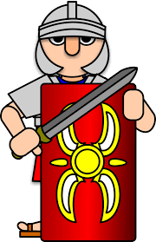 | History | Democracy and Dictatorship – Germany 1890-1945  Health and Medicine | Health and Medicine  Site Study | Site Study  Revision
 | Humanities | Climate Change | Prejudice and Discrimination against people | Preparing portfolios for assessment  Working as part of a group
 | P.E. | Dodgeball  Badminton | Trampolining  Fitness/Cricket | Rounders  Athletics  Tag Rugby
 | RE | Christianity, Jesus and non-religious responses  Who was Jesus?  Life in a Muslim family  Life in a Jewish family | Hindu Dharma  What is the purpose of life?  Belonging to a Sikh family  Christianity: Church  What beliefs are central to Christianity? | Buddhism  Is suffering a necessary part of the human experience?  Judaism  What does it mean to be the ‘Chosen people’?
 | PHSCE | Health & Wellbeing  Promoting self-esteem and coping with stress  Careers Lesson/s  Decision Making  Self-awareness recap of skills and interests including how to prove my employability skills  Opportunity Awareness – apprenticeships, traineeships, college | Living in the Wider Community  Skills for employment and career progression  Careers Lesson/s  CV Writing / updating and covering letters  Application forms | Health & Wellbeing  Health and Safety  Careers Lesson/s  Interview preparation  Financial support for students  Evaluation  www.youthemployment.uk
 | DofE: Silver Award | Taking part in individual sports | Learning a new skill | Volunteering / Preparing for the expedition
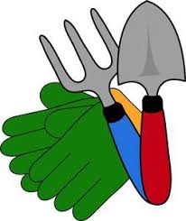 | Gardening | Planting in the Garden | Planting in the Garden  Careers on Gardening | Careers on Gardening
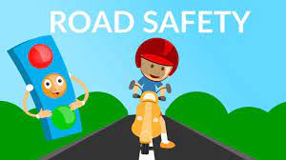 | Travelling Independently | Crossing roads safely and independently (Group 1)  Preparing yourself for a journey using public transport (Group 1) | Travel independently on a chosen journey (Group 1)  Crossing roads safely and independently (Group 2) | Preparing yourself for a journey using public transport (Group 2)  Travel independently on a chosen journey (Group 1)

