YEAR 8 |  | Autumn
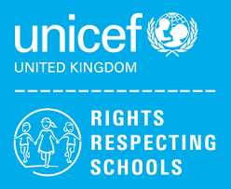 | Rights of the Child | Article 29 (goals of education) Education must develop every child’s personality, talents and abilities to the full. It must encourage the child’s respect for human rights, as well as respect for their parents, their own and other cultures, and the environment.
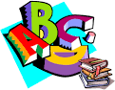 | English | 8MS – Stories and Poetry from Other Cultures.  8CB- Stories and Poetry from Other Cultures.
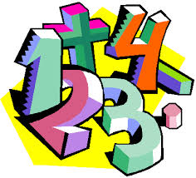 | Maths | 8MS – Place Value, Addition & Subtraction, shape  8CB - Place Value, Addition & Subtraction, Measurement Area, Multiplication and Division
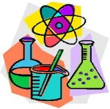 | Science | 8MS – Health & The Human Body  8CB- Health & The Human Body
 | Computing/ICT | Kid’s Club – Creating a Survey/Gathering Information, Powerpoint Presentations
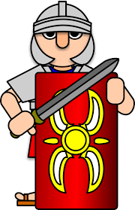 | Wider World | History- Industrial Revolution  Geography- Economics  MFL- Core language, Family Members and Personal Information
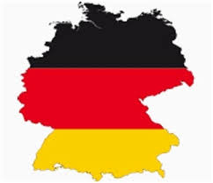 | MFL | Recap core language, rooms in a school, classroom objects, personal info
 | Practical Learning | Managing my money
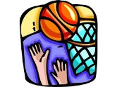 | P.E. | Basketball / Orienteering  Dodgeball Badminton
 | Design Tech | Structures/Desk tidy
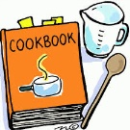 | Food Tech | Mini-Enterprise  Designing and running  a Food Outlet  Healthy Living
 | Creative Studies Art | Mixed Media – Stained Glass Windows
 | Creative Studies Music | Pop/Soul music
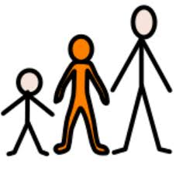 | Preparing for Adulthood | P4A – Good Health – Alcohol and drug misuse and managing peer pressure. Community Inclusion – The Law, Legal & Illegal substances. Rights and Responsibilities in the community. Independent Living – Household cleaning, Transport including buses, directions and timetables.
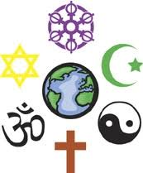 | RE | 8CB – Beliefs & Values – Christianity – Why is it sometimes difficult to do the right thing?

