YEAR 14 |  | Autumn
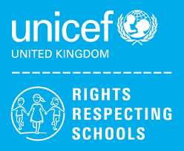 | Rights of the Child | Article 29 (goals of education) Education must develop every child’s personality, talents and abilities to the full. It must encourage the child’s respect for human rights, as well as respect for their parents, their own and other cultures, and the environment.
 | English | Year 14 – AQA Functional skills English Level 1 Writing
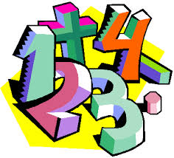 | Maths | Y14 Ascentis Maths Skills Level 1 – Understanding and Using 2D Shapes
 | Employability  Level 1 | Health and Safety Practices in Vehicle Maintenance
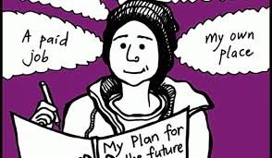 | Preparing for Adulthood | Travelling Independently  Individual Work Experience Placements
 | Computing/ICT | Y12/13/14 (L) – WJEC Entry Pathways E3 Certificate – Spreadsheet Software, Database Software, Desktop Publishing Software  Y12/13/14 (H) – WJEC Entry Pathways E3 Certificate – Using Email, Internet Fundamentals  Y12/13/14 (H) - WJEC Entry Pathways Level 1 Award – Word Processing Software, Presentation Software

