Pupil Premium Analysis Report

2018-19

Ashley High School

This report was compiled October 2019
To be reviewed: October 2020

PUPIL PREMIUM ANALYSIS REPORT 2018-19

Who are the Pupil Premium students and what are their barriers to learning 2018-19?

All our students have an EHC plan with a diagnosis of Autism and/or Social Communication needs. Many pupils have other additional overlapping needs such as SpLD, ADHD, Attachment issues or SEMH (Social Emotional Mental Health). Many students have associated emotional needs with high levels of anxiety.
The school holds an accurate SEND register of all pupils and this information is used to assist in data analysis. Comparative data is produced for Pupil Premium versus Non PP students.
The population in receipt of Pupil Premium funding in the school fluctuates throughout the year. For reporting purposes this 2018-19 analysis report is based on a total of 80 pupils on roll Year 7-11.
Percentages of eligible pupils (Autumn 2018)
TOTAL pupils on roll Y7 -11 | 80
Eligible PP pupils | 38
Overall % (FSM/Ever 6/Post LAC) | 45%
Overall % (inc. LAC) | 47.5%
Of these eligible pupils (38)
FSM | 66% | 90% in total
Ever 6 | 24%
LAC | 5%
Post LAC | 5%
Armed Forces | 0%

Barriers to learning for eligible/non-eligible pupils 2018-19
SEND across the school | Pupil Premium  2018 | Non PP  2018 | % of 80 on roll 2018
ASC | 58% | 81% | 70%
Social Communication/SLCN | 58% | 31% | 44%
MLD/Cognition & Learning | 13% | 2% | 8%
SEMH/Social Emotional | 21% | 21% | 20%
SpLD (eg Dyslexia) | 5% | 2% | 4%
ADHD | 37% | 5% | 20%
NOTE: Many pupils have comorbid diagnosis with more than one SEND need identified

Comparative data from 2016-18
SEND needs of eligible PP pupils | Percentages of total eligible 2016 | 2017 | 2018
ASC | 64% | 57% | 58%
Social Communication/SLCN | 48% | 57% | 58%
MLD/Cognition & Learning | 12% | 6% | 13%
SEMH/Social Emotional | 15% | 17% | 21%
SpLD (eg Dyslexia) | 0% | 6% | 5%
ADHD | 27% | 32% | 37%
NOTE: Many pupils have comorbid diagnosis with more than one SEND need identified
- ASC and SLCN groups still highest within PP group (58%)
- Ongoing rise in numbers of PP pupils with social and emotional needs (+ 4% since 2017/18)
- Ongoing rise in numbers of PP with ADHD (+ 5% since 2017/18)

Breakdown % of PP pupils accessing following PP funded interventions
- 71% accessed SALT support
- 40% accessed Emotion Coach support
- 35% accessed School Counsellor support

Evidence of Impact Measures
Through strategic use of the Pupil Premium grant funding, focusing on the identified barriers for this disadvantaged group, we are able to facilitate students achieving their potential resulting in improved attainment and progress both academically and personally.

For some students case studies are also compiled using both quantitative and qualitative data. These personalised case studies demonstrate positive impact on students’ ability to manage their own behaviour, interact with others and develop confidence and independence skills.
Data Analysis for Core Subjects 2018-19

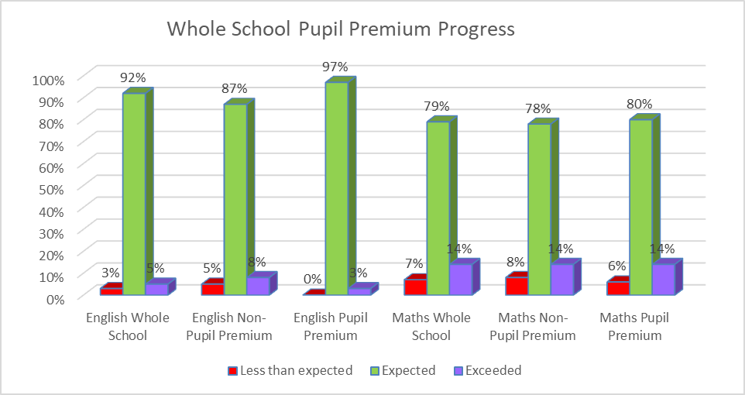

- Out of 73 learners across Key Stage 3 and 4, 49% were Pupil Premium pupils. Pupil Premium pupils made good progress and in general are in line with their non-pupil premium peers. There are no significant gaps in attainment.

Areas for Improvement
- As there are no significant gaps or differences in the achievement of Pupil Premium pupils, the focus will be to maintain this level of progress.

English Data Analysis 2018-19
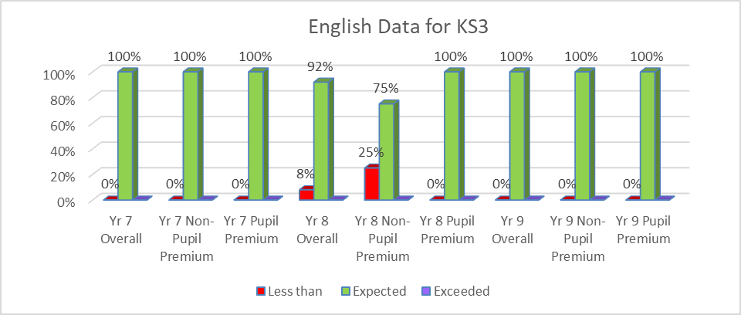
- Pupils across Key Stage 3 are making good progress in English. This is a significant improvement on last year’s progress. In 2017-18, every year group had a percentage of pupils who did not achieve their individual progress target. Now only year 8 have less than 100% of pupils achieving this.
- Pupil premium learners in Year 8 are performing better than their non-pupil premium peers

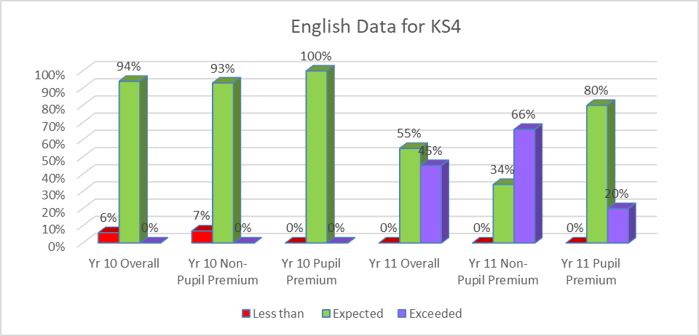

- Pupils across Key Stage 4 are making excellent progress. There is a significant improvement for Yr 11 from last year’s progress data (the number of pupils exceeding expected progress in particular)
- Pupil Premium Pupils in Year 11 are making excellent progress

Maths Data Analysis 2018-19

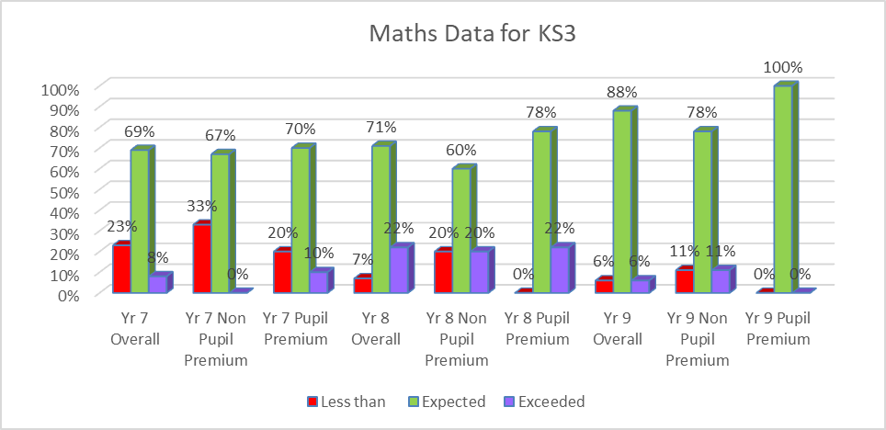
- Pupils made good progress in Years 8 and 9.
- Pupils in Year 7 generally made good progress. The percentage of pupils that did not make expected progress represents 2 pupils. One of which has SEMH and found transition difficult and the other who made progress within Maths stages but did not quite reach target. Both pupils will be given targeted intervention in the academic year 2019-20
- Pupil premium learners are making good progress but are at times exceeding their peers in Key Stage 3

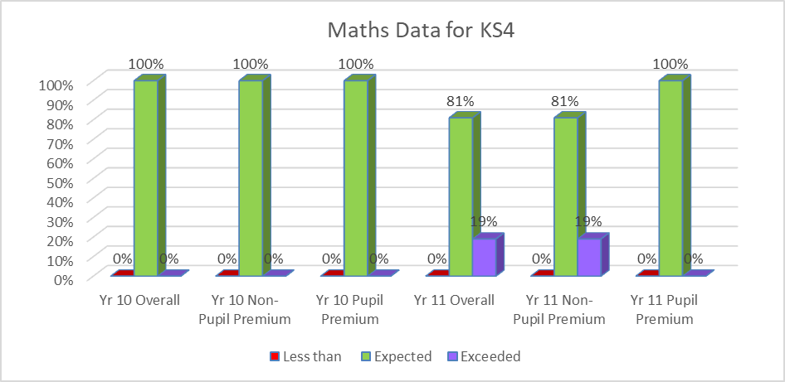

- Very good progress is made across Key Stage 4
- Pupil premium learners are in line with their their non-premium peers across the key stage

Analysis of LAC data 2018-19
Key Stage | Less than Expected Progress | Expected Progress | Exceeded Expected Progress
KS4 English | 0% | 100% | 0%
KS4 Maths | 0% | 100% | 0%

- LAC pupils make very good progress and are in line with their peers

Progress Summary Statement
- Pupil Premium learners are making the same if not more progress overall than their non-pupil premium peers
- LAC pupils in receipt of Pupil Premium Plus funding are making very good progress in line with their peers

Attendance Analysis for Pupil Premium students 2018-19

2018-19 | Overall attendance | Persistent absence  (absent for 10% or more of sessions)
PP | 92.8% | 20.6% (7 pupils)
Non PP | 91.5% | 26.4% (14 pupils)

- Pupil Premium students attendance was higher than Non PP students
- Persistent absence of PP students was less than that of Non PP students

________________________________________________________________________________

