YEAR 10 |  | Autumn | Spring | Summer
 | Rights of the Child | Article 29 (goals of education) Education must develop every child’s personality, talents and abilities to the full. It must encourage the child’s respect for human rights, as well as respect for their parents, their own and other cultures, and the environment. | Article 29 (goals of education) Education must develop every child’s personality, talents and abilities to the full. It must encourage the child’s respect for human rights, as well as respect for their parents, their own and other cultures, and the environment. | Article 29 (goals of education) Education must develop every child’s personality, talents and abilities to the full. It must encourage the child’s respect for human rights, as well as respect for their parents, their own and other cultures, and the environment.
 | English | Speaking and Listening – Presentation Skills | Functional Skills Reading | Functional Skills Reading Continued
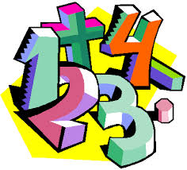 | Maths | 10L Functional Skills (Entry Level)  Place Value  Addition & Subtraction  Multiplication & Division  10RH Functional Skills (Level 1)  Using numbers & number system  Place Value  Addition, Subtraction, Multiplication & Division  Order of operations  Fractions  Decimals  Percentages | 10L Functional Skills (Entry Level)  Multiplication & Division continued  Length & Perimeter  Fractions  Mass & Capacity  10RH Functional Skills (Level 1)  Using numbers and number system continued  Equivalent F.D.P  Ratio and Proportion  Measures  Money  Interest  Correct measures  Area & Perimeter  Volume | 10L Functional Skills (Entry Level)  Fractions continued  Money  Time  Shape  Statistics  10RH Functional Skills (Level 1)  Measures  Symmetry  Plans & Elevations  Angles  Data  Discrete data  Grouped data  Data calculations  Probability
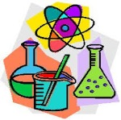 | Science | Entry Level  C1 The Human Body – Theory  C1 The Human Body – ESA and TDA investigations  Open Award  Human Body | Entry Level  C3 Elements, Mixtures and Compounds – Theory  C3 Elements, Mixtures and Compounds – ESA and TDA investigations  Open Award  Elements & Compounds | Entry Level  C5 Energy, Forces and Structures of Matter – Theory  C5 Energy, Forces and Structures of Matter – ESA and TDA investigations  Open Award  Electrical Circuits & Components
 | Computing/ICT | 10L –Digital Functional Skills @ E3 – Using devices and handling information / Creating and Editing  10RH – Digital Functional Skills @ Level 1 – Using devices and handling information / Creating and Editing | 10L – Digital Functional Skills @ E3 – Using devices and handling information / Creating and Editing  10RH – Digital Functional Skills @ Level 1 – Using devices and handling information / Creating and Editing | 10L – Digital Functional Skills @ E3 – Communicating  10RH – Digital Functional Skills @ Level 1 - Communicating
 | Humanities | Responding to a Tectonic Event (10L) (10RH) | Responding to a Tectonic Event (10RH/10L)  Changing Population (10RF) (10RH)  People and Protest (10RH/10L) | People and Protest (10RH) (10L)
 | P.E. | Dodgeball  Basketball | Fitness  Trampolining | Athletics  Rounders  Cycling / Walking
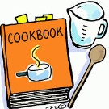 | Food Technology | Home cooking skills  Planning a two course meal  Methods of Cookery | Home cooking skills  Preparing and cooking a two course meal  Healthy Eating | Home cooking skills  Economising & Shopping  Passing on information
 | Creative Media | Ceramics  LO1 Record experiences  LO2 Evidence of Ideas | Ceramics  LO3 Evidence of an appropriate ceramic outcome | Film Genres  LO1 How films are grouped in Genres  LO2 Key Conventions  LO3 Produce an idea for a new film
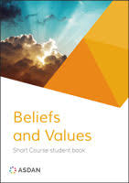 | Beliefs and Values | Values, Beliefs and Decision Making | Crime and Punishment | Environment
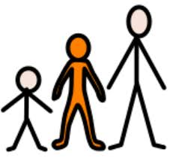 | Preparing for Adulthood | Health & Wellbeing  Mental health and ill health, tackling stigma, building resilience  Independent Living Skills  Digital footprint presence  Digital skills in the workplace  RSE  The benefits of regular self-examination and screening  Physical wellbeing  Healthy/Unhealthy relationships  Stress management | Relationships  Managing change, grief and bereavement  Managing relationship challenges including break ups  Relationship myths and expectations  Careers Lesson/s  Raising aspirations and stereotyping (1 lesson)  RSE  The facts about reproductive health including fertility and the potential impact of lifestyle on fertility for men and women and the menopause  Self examination  Careers Lesson/s  Employer Talk (1 lesson) | Relationships  Personal values and assertive communication in relationships  Tackling domestic abuse and forced marriage  RSE  Characteristics and legal status of other types of long-term relationships  Healthy relationships and consent  Risks of STIs, sexting and pornography  Careers Lesson/s  What makes you tick – personality test and job values (1 lesson)  Good Health  Resilience  Community Inclusion  Diversity & Inclusion
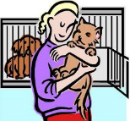 | Animal Care | Animal Investigation / Safety Around Animals  Safety Around Animals / Looking after Animals | Looking After Animals / Animals in Trouble  Looking After Animals / Animals and The Law | Animals and The Law / Careers in Working with Animals
 | DofE: Bronze Award | Taking part in team sports | Learning a new skill  (Camp craft + Navigation skills) | Volunteering / Preparing for the expedition
 | Preparation for Work | Construction  General Construction Operations  Bricklaying | Construction  Carpentry  Painting and Decorating | Construction  Health and Safety  Careers in Construction
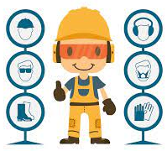 | Preparation for Work | Health & Safety  Designing | Designing  Making | Making  Evaluating
 | Hospitality | Hospitality Services  Food and Beverage Services | Food and Beverage Services  Housekeeping and Front Office | Careers in Hospitality  Events
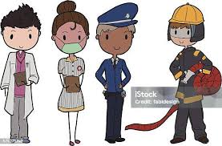 | Uniformed Public Services | Military  Army  Navy  RAF | Fire & Rescue Service | Police & Policing

