**Saturday**

**28th Jan**

**25th Feb**

**25th Mar**

10am – 3pm

**29th Apr**

**27th May**

**24th Jun**

10am-2pm

Lunch and refreshments will be supplied.

**S**

**-**

**SEND Friendly**

**SA**

**-**

**SEND Accessible**

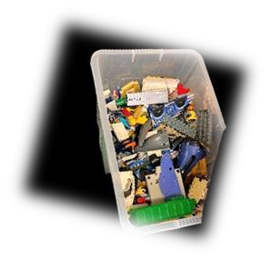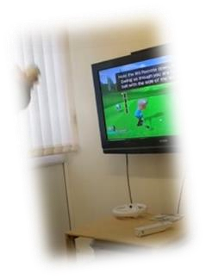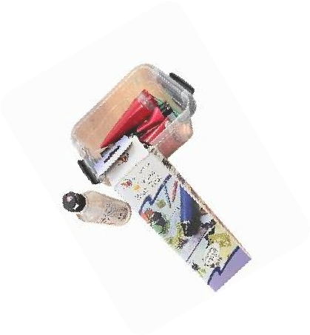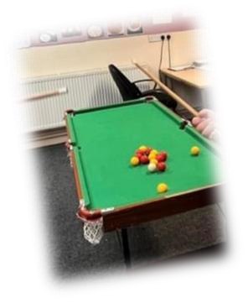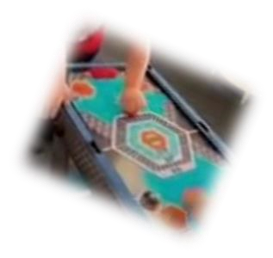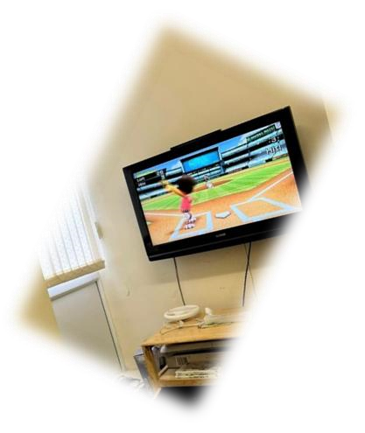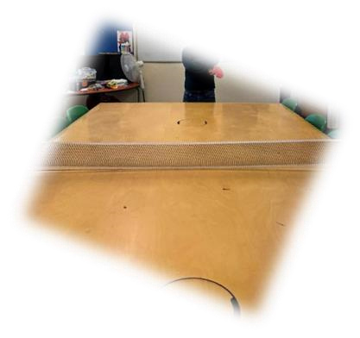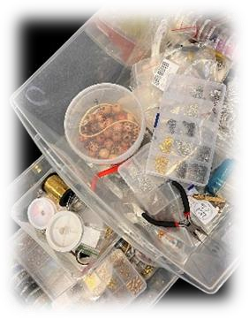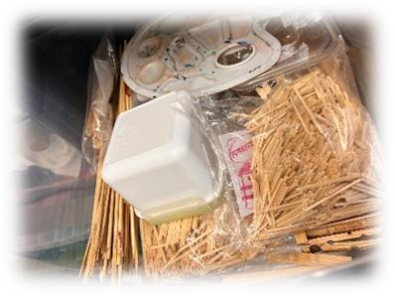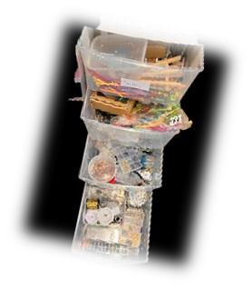

Calling all 11

–

25

-

year

-

olds!

Come and join us in a safe and all inclusive

Activity Hub on …

**Zone 1**

–

will be a social space to relax, talk to

friends, YP will be able to bring their own

electronics i.e., switch, iPad, phones etc. This

space will also have timetabled Movie, pool, table

football time etc.

**Zone 2**

–

Craft room, YP will be able to use the

craft room for a multitude of crafts ranging from

Jewellery making, painting, drawing, paper

quilling, papermaking, soap, and candle making

etc.

**Zone 3**

–

many board games will be available

throughout the evening session; we will also have

available table tennis and safe darts tournaments.

**Zone 4**

–

Kitchen will be available for bookable

slots for cooking skills

**Zone 5**

–

Gaming room 1 hr booking slots

, Wii, PS

available

and

much more……………..



Hallmark House

Waterloo Road

Widnes

WA8 0QR

0151 4220111

gatewayc2017@outlook.com

**Call or email to book your**

**place**

[/](https://www.gatewaycommunity.co.uk/)

[https://www.gatewaycommunity.co.uk](https://www.gatewaycommunity.co.uk/)

**Youth Provision**

**Activity Hub**