Student Code of Conduct
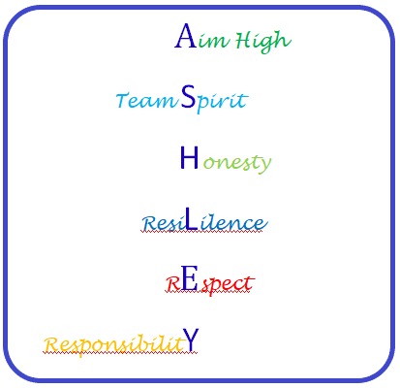

Students, please read this document and sign below
As a student I will –
- Arrive at school and to lessons every day, on time and ready to learn
- Try my best to do my work, ask for help if I need it and accept support and advice from staff
- Wear the correct school uniform
- Follow school rules (see below) and staff instructions
- Look after school equipment, and show respect for the school environment and local community
- Be a champion of the 6 Ashley High School core values –

- Aim High
- Team Spirit
- Honesty
- Resilience
- Respect
- Responsibility

Ashley High School Rules

- AIM HIGH
I will work hard, try my best and challenge myself, even when things seem difficult. I will try to work as independently as possible.

- TEAM SPIRIT
I will work together with staff and other students to encourage each other and do the very best we can as a group.

- HONESTY
I will tell the truth, even if I make mistakes. That way I can be trusted and I can trust other people.

- RESILIENCE
I will learn to cope with things if they go wrong and understand that it is OK to make mistakes, as long as I keep trying my hardest.

- RESPECT
I will behave and communicate in a kind way and treat everyone as equals, making sure my words and actions do not upset or hurt others, or stop them from learning.

- RESPONSIBILITY
I will be a positive role model to other people and look after them. I will make good choices and accept the results of my actions.

Signed __________________________ (Student) Date _____________________

