YEAR 8 |  | Autumn | Spring | Summer
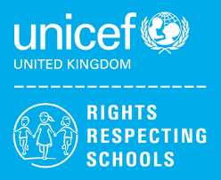 | Rights of the Child | Article 29 (goals of education) Education must develop every child’s personality, talents and abilities to the full. It must encourage the child’s respect for human rights, as well as respect for their parents, their own and other cultures, and the environment. | Article 29 (goals of education) Education must develop every child’s personality, talents and abilities to the full. It must encourage the child’s respect for human rights, as well as respect for their parents, their own and other cultures, and the environment. | Article 29 (goals of education) Education must develop every child’s personality, talents and abilities to the full. It must encourage the child’s respect for human rights, as well as respect for their parents, their own and other cultures, and the environment.
 | English | Other Cultures – Stories  Other Cultures - Poetry | Modern Play/Drama – Our Day Out/Blood Brothers | Travel Writing – Non-Fiction Texts  (Emails & Letters, Brochures & Adverts, Reviews)  Speaking & Listening
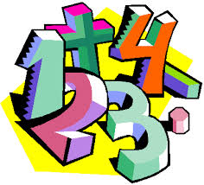 | Maths | Place Value (8LQ) (8MS) (8AC)  Addition & Subtraction (8LQ) (8MS) (8AC)  Area (8LQ)  Multiplication and division (8LQ)  Geometry (shape) (8MS) (8AC) | Multiplication & Division (8LQ) (8MS) (8AC)  Length & perimeter (8LQ)  Fractions (8LQ)  Decimals (8LQ)  Length & height (8MS) (8AC)  Mass, capacity and temperature (8MS)  Money (8MS) (8AC)  Place value 20-1 (8AC)  Addition & Subtraction (8AC)  Place value 50-1 (8AC)  Measures (8AC) | Decimals (8LQ)  Money (8LQ) (8AC)  Time (8LQ) (8MS) (8AC)  Shape (8LQ)  Statistics (8LQ) (8MS) (8AC)  Position & Direction (8LQ)  Fractions (8MS) (8AC)  Geometry (position & direction) (8MS) (8AC)  Multiplication & Division (8AC)
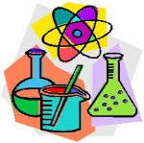 | Science | Health and Human Body  Chemical Reactions | Electricity and Magnetism  Respiration and Photosynthesis | Earth’s Atmosphere  Space
 | Computing/ICT | After School Club – Creating a Survey / Gathering Information  Powerpoint Presentations | JustBasic Computer Programming  Desktop Publishing – Creating a leaflet | Spreadsheet Modelling  Data Handling
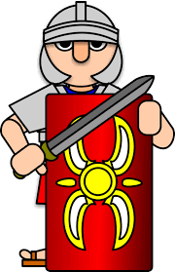 | The Wider World | Geography  World development (8AC) (8MS)  History  Health and Medicine (8AC)  Transatlantic Slave Trade (8LQ)  MFL  Welcome to School, My Town, Family Tree (8MS) (8LQ) | MFL  Welcome to School, My Town, Family Tree (8AC)  Body Parts, Feeling Unwell, The Weather (8MS)  Geography  Kenya (8AC)  World development (8LQ)  History  Health and Medicine (8MS) (8LQ) | History  Transatlantic Slave Trade (8AC) (8MS)  MFL  Body Parts, Feeling Unwell, The Weather (8AC) (8LQ)  Geography  Kenya (8MS) (8LQ)
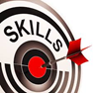 | Practical Learning | Life Skills Challenge  Managing my Money  - How much do things cost?  - Luxury or Necessity  - Shopping Essentials  - Price Comparisons  - Visit to Local Shops  - Visit to Supermarket  (Comparing Prices)  LOTC – Local Area  Library Visit  Kingsway Leisure Centre  Victoria Park/Coffee Shop  Widnes Town Centre  Shopping City Runcorn  Dr’s/Chemist  The Hive | Gardening  Planting in the Garden  Using Produce  Wildlife in the Garden  Art in the Garden  Halton Community Project  Life Skills Challenges – Literacy, Numeracy & Digital Skills  Practical Literacy Skills – Writing  Practical Literacy Skills – Reading  Practical Numeracy Skills – Time  Practical Numeracy Skills – Measurement  Digital Skills | Forest School - Intermediate  - Introduction to health and safety  - Woodcraft  - Shelter building  - Fire  - Nature  - Ropes
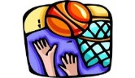 | P.E. | Basketball  Orienteering  Dodgeball  Badminton | Health Related Fitness  Trampolining  Hockey  Cricket | Rounders  Athletics  Walking  Cycling
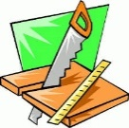 | Design Technology | Health & Safety  Structures  (8A)  Desk Tidy  (8A) | Mechanisms (Levers)  (8A)  Health & Safety  Structures  (8B) | Desk Tidy  (8B)  Mechanisms (Levers)  (8B)
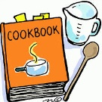 | Food Technology | Designing a Food Outlet & Mini – Enterprise  Mini-Enterprise & Healthy Living | Mini-Enterprise & Health and Safety  Mini-Enterprise & Designing a Food Outlet | Mini-Enterprise & Food Nutrition  Mini-Enterprise & Health and Safety
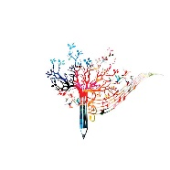 | Creative Studies  Art | Mixed Media  Stained Glass Windows | Artist Study  Gustav Klimt | Collage  Eric Carle Minibeasts & Clay Project
 | Creative Studies Music | Pop/Soul Music | Keyboard Practical | Rock Anthems
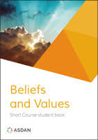 | Beliefs and Values | Christianity, Jesus and non-religious responses  Who was Jesus?  Islam  How do the Qur’an and Hadith guide Muslim life? | Hindu Dharma  What is the purpose of life?  Christianity: Church  What beliefs are central to Christianity? | Buddhism  Is suffering a necessary part of the human experience?  Judaism  What does it mean to be the ‘Chosen people’?
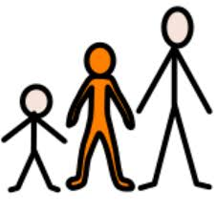 | Preparing for Adulthood | Good Health  Alcohol and drug misuse and managing peer influence  Community Inclusion  The law and legal and illegal substances  Rights and Responsibilities in the Community  Independent Living  Household Cleaning  Transport – Buses/Directions | Community Inclusion  Strategies for safely challenging stereotyping, prejudice, bigotry, bullying and discrimination  Good Health  Mental Health and Resilience, Emotional Wellbeing including Body Image  Independent Living  Common Ailments/Medical Appointments  Employment/Careers  Introduction to the Careers Advisor and the A-Z of Careers  Skills and Qualities  Community Inclusion  British Law and Cultural and Religious Expectations and Practices | Good Health  Managing Change and Loss  Community Inclusion  My own Core Values  Tackling Age and Disability Discrimination  Independent Living  Knowledge of Community Resources/Emergency and Safety Skills  Employment/Careers  Careers Lessons/STEM Talk  Community Inclusion  All individuals have the same rights and opportunities in education and the workplace

