YEAR 9 |  | Autumn | Spring | Summer
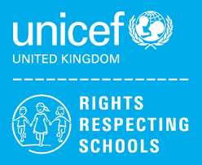 | Rights of the Child | Article 29 (goals of education) Education must develop every child’s personality, talents and abilities to the full. It must encourage the child’s respect for human rights, as well as respect for their parents, their own and other cultures, and the environment. | Article 29 (goals of education) Education must develop every child’s personality, talents and abilities to the full. It must encourage the child’s respect for human rights, as well as respect for their parents, their own and other cultures, and the environment. | Article 29 (goals of education) Education must develop every child’s personality, talents and abilities to the full. It must encourage the child’s respect for human rights, as well as respect for their parents, their own and other cultures, and the environment.
 | English | Classics – A Christmas Carol | Descriptive / Narrative Writing  Shakespeare – Romeo and Juliet | Contemporary Fiction – Refugee Boy / Terror Kid / Ghost Boys etc  Speaking & Listening
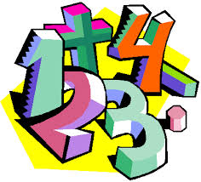 | Maths | Place value  Addition & subtraction  Multiplication & division  Fractions (JO)  Place value  Addition & subtraction  Measurement – area  Multiplication & division (CB)  Number calculations  Sequences and equations  Statistics  Fractions, decimals and percentages (SCP) | Shape  Position & direction  Decimals  Negative numbers  Converting units  Volume (JO)  Decimals  Money  Time  Shape  Statistics  Geometry – position + direction (CB)  Geometry in 2D and 3D  Algebraic and real-life graphs  Multiplicative reasoning  Algebraic and geometric formulae (SCP) | Multiplication & division  Fractions  Decimals & percentages  Perimeter  Statistics (JO)  Multiplication & division  Measurement – length + perimeter  Fractions  Decimals (CB)  Probability  Polygons and transformations (SCP)
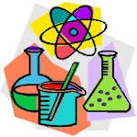 | Science | Inheritance and Evolution  Ecosystems and Interdependence | Acids and Alkalis  Materials and Recycling | Motion and Pressure  Waves
 | Computing/ICT | Hardware / Software  Multimedia ICT Presentations  Scratch Programming Part 1 | Powerpoint Presentations  Databases | Spreadsheet Modelling  Scratch Programming Part 2
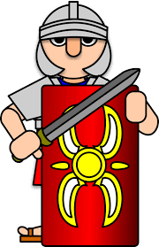 | History | The Second World War and the Holocaust | People and Protest:  20th Century Civil Rights Movements in USA and South Africa | Halton Throughout History
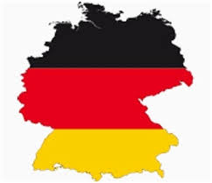 | MFL | Wo wohnst du?  Where do you live?  Mein Haus – My house | Wo ist es?  German prepositions  Wo liegt das?  Study of German city | Wo ist der Markt?  Types of transportation  Boardgames in German
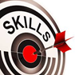 | Practical Learning | Geography  Japan  Climate Change  Global Warming  Themed Days  World Habitat Day  Independent Living  Health – Sleep  Housekeeping – Looking after pets & tidying my own space  Money Management – Basic budgeting, Wages | Geography  Environmental Issues  Independent Living  Personal appearance, washing and drying clothes  Maps and timetables, using Google maps, planning meals  Gardening  Wonky Garden Project – 5 weeks | Geography  Rivers, Weather, erosion  Independent Living  Basic first aid, CPR  Geography  Geography investigations  Independent Living  Interpersonal skills; talking on the phone, speaking to strangers  Emotional wellbeing; where to get support
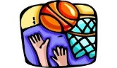 | P.E. | Basketball  Team building  Dodgeball  Badminton | Health Related Fitness  Trampolining  Hockey  Tag Rugby | Rounders  Athletics  Cycling  Walking
 | Design Tech | Mechanisms (Cams) (9JO)  Jigsaw (CAD/CAM) (9JO) | Electronics (SHG) (9JO)  Mechanisms (Cams) (9KD) | Jigsaw (CAD/CAM) (9KD)  Electronics (SHG) (9KD)
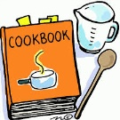 | Food Tech | Individual Cooking Skills  Nutrition & Health  (9KD) | Home Cooking  Fast Food Project  (9KD)  Individual Cooking Skills  Nutrition & Health  (9JO) | Individual Cooking Skills  Nutrition & Health  (9J0)  Home Cooking  Fast Food Project  (9J0)
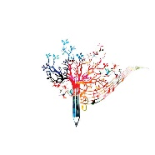 | Creative Studies  Art | African Art  2D Relief Masks & Printing | Hunderwasser | Ceramics
 | Creative Studies Music | Pop/Soul Music (Happy)  Ukulele Practical | Rock Anthems (Don’t Stop Believing)  Songs about Civil Rights (Blackbird) | Keyboard Practical  Pop Ballads (Make you feel my love)
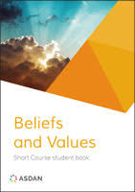 | Beliefs and Values | Christianity(God)  How do Christians mark the ‘turning points’ on the journey of life?  Hindu Dharma  Is there one journey or many? | Islam  What is Hajj and why is it important to Muslims?  Christianity (Jesus)  Why do Christians believe Good Friday is ‘good’? | Buddhism  What do we mean by a ‘good life’?  Christianity (Church)  If life is like a journey, what’s the destination?
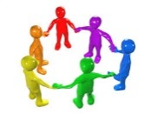 | PHSCE | Health & Wellbeing  Peer pressure, assertiveness and risk, gang crime  Living in the Wider World  Understanding careers and future aspirations | Relationships  Managing conflict at home and staying safe  Careers Lesson/s  Choosing options – Introduction to the careers websites linking subjects to careers  Relationships  Tackling homophobia, transphobia and sexism  Careers Lesson/s  Using the Start website to view films on a variety of employers and job roles (1 lesson) | Health & Wellbeing  Managing peer pressure  Careers Lesson/s  Employer Talk  Living in the Wider World  Planning and carrying out an Enterprise Project
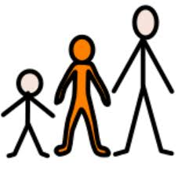 | Preparing for Adulthood | COMMUNITY INCLUSION  Peer pressure, assertiveness and risk, gang crime  EMPLOYMENT / CAREERS  Understanding Careers and Future Aspirations  INDEPENDENT LIVING  Sleep  INDEPENDENT LIVING  Washing/Drying Clothes  Housekeeping – Fire Prevention / Changing Light Bulbs | COMMUNITY INCLUSION  Managing conflict at home and staying safe / Diversity, Prejudice and Bullying / Tackling homophobia, transphobia and sexism  INDEPENDENT LIVING  Basic Budgeting Skills  EMPLOYMENT  Introduction to the Careers Service  START Website  INDEPENDENT LIVING  Planning Meals  Transport – Using Google Maps | EMPLOYMENT / CAREERS  Planning and Carrying out an Enterprise Project / Employer Talk  COMMUNITY INCLUSION  Managing peer pressure  INDEPENDENT LIVING  Basic First Aid / First Aid Kits  INDEPENDENT LIVING  Using the telephone / Talking to unfamiliar people  Emotional Wellbeing

