YEAR 10 |  | Spring
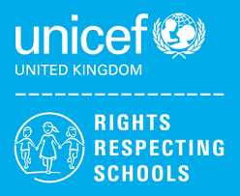 | Rights of the Child | Article 29 (goals of education) Education must develop every child’s personality, talents and abilities to the full. It must encourage the child’s respect for human rights, as well as respect for their parents, their own and other cultures, and the environment.
 | English | 10L – Step Up Component 1 – Reading and Writing Non – Fiction  Functional Skills Writing Skills  10LQ – GCSE English Language – Paper 1 Section B Creative Writing
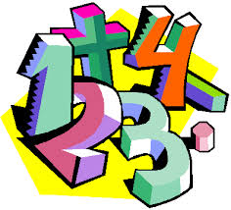 | Maths | 10LQ – Number, Algebra, Geometry & Measures, Ratio, Probability, Statistics  10L – Working with Fractions, Working with Angles
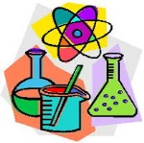 | Science | GCSE: Chemical Changes, Particle model of matter, Bioenergetics, Energy Changes  ELC: Chemicals in our World
 | Computing/ICT | 10LQ – EdExcel ICT Functional Skills Level 2 exam preparation  10L – WJEC Entry Pathways Modules – Word Processing Software/Using Presentation Software/Using Spreadsheet Software
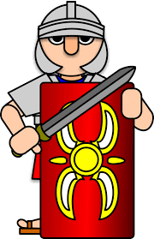 | History | GCSE – The Norman Conquest 1066-1100
 | Humanities | Population
 | P.E. | PE – Fitness, replication of movement in Trampolining
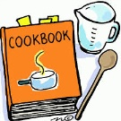 | Food Tech | Home Cooking Skills  BTEC Level 1  Cooking a two course meal & Methods of cookery
 | Creative Media | Ceramics Project  Natural Form
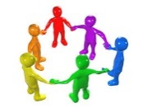 | PHSCE | Health & Wellbeing  Exploring relationships, change, loss and bereavement
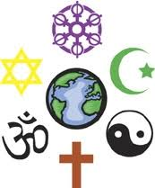 | RE | Contentious issues
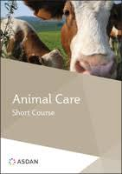 | Animal Care | Asdan – Short Course
 | Preparation for work | WJEC – Making
 | Duke of Edinburgh | DofE – Introduction  Section 2 – Skills – Camp craft and basic navigation

