 | Literacy/  Numeracy  Time  9:00 – 9:30 | Lesson 1  9:30 – 10:20 | 7LA Timetable 2025-2026  Break  10:20 -10:35 | Lesson 2  10:35 – 11:30 | Lesson 3  11:30 – 12:20 | Lunch  12:20 – 12:55 | Lesson 4  12:55 – 1:20 | Lesson 5  1:20 – 2:10 | Lesson 6  2:10 – 3:00
Monday |   Hall |   ICT |  |   Creative Studies | Creative Studies |  | 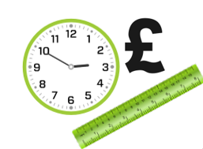    Numeracy |   PE |   PE
Tuesday |   Guided Reading |   English |  |   Maths |   Science |  |   British Values/  Current affairs | 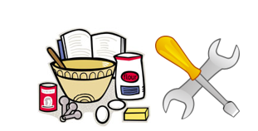  DT/FT  Room 8/9 | DT/FT  Room 8/9
Wednesday |   Numeracy | English |  | Maths |   Science |  |   Literacy |   WiderWorld |   WiderWorld
Thursday |   Literacy |   P4A |  |   P4A | P4A |  | Numeracy | English | Maths
Friday |   Pastoral time |   Practical  Learning |  |   Practical  Learning | Practical Learning |  |   Pastoral  Credits |   Beliefs and Values |   Reward Time

