11GG | 9:00 – 9:30 | Lesson 1  9:30 – 10:20 | Break  10:20-10:35 | Lesson 2  10:35-11:30 | Lesson 3  11:30-12:20 | Lunch  12:20-12:55 | Lesson 4  12:55 – 1:20 | Lesson 5  1:20 – 2:10 |  | Lesson 6  2:10 – 3:00
Monday |  |   PE |  | PE |   Maths |  | 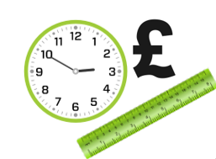    Numeracy  P4C |   English |   Humanities
Tuesday |   Pastoral/ Literacy | Humanities |  | Gardening/Construction    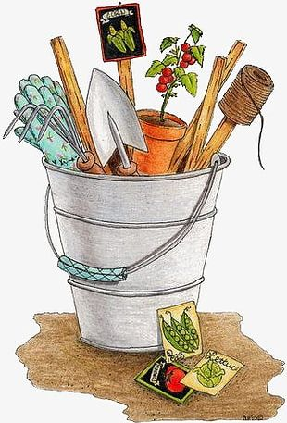 |  |  |   Current Affairs British Values  P4C | Science  
Wednesday | Pastoral/ Numeracy | Science |  |   PHSCE |   Beliefs & Values |  | 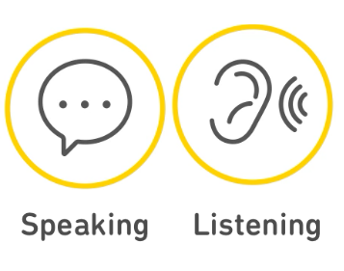  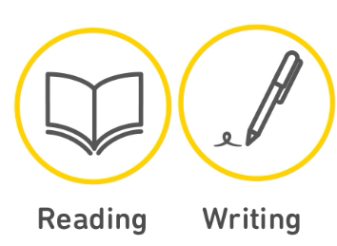  Literacy  P4C | English |  | Maths
Thursday | Pastoral/ Literacy | Maths |  | 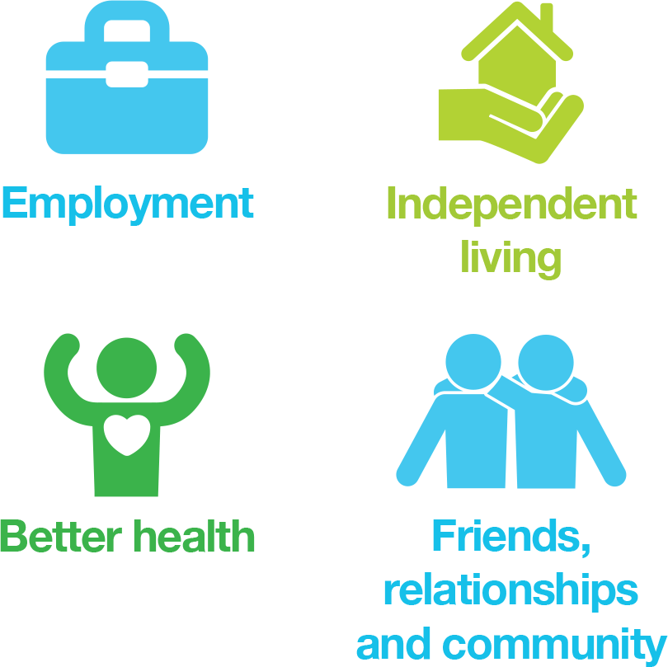  P4A | English |  | Numeracy  P4C |   Ind Living/Travel  P4C  
Friday | Pastoral | English |  | Maths | Humanities |  | Pastoral  P4C |   ICT |  | 

