 | Literacy/  Numeracy  Time  9:00 – 9:30 | Lesson 1  9:30 – 10:20 | 7CB Timetable 2025-2026  Break  10:20 -10:35 | Lesson 2  10:35 – 11:30 | Lesson 3  11:30 – 12:20 | Lunch  12:20 – 12:55 | Lesson 4  12:55 – 1:20 | Lesson 5  1:20 – 2:10 | Lesson 6  2:10 – 3:00
Monday |   Hall | English  Room 12 |  |   Maths  Room 12 |   Science  Room 12 |  | 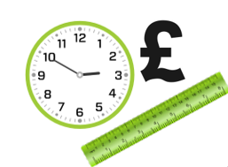    Numeracy |   Wider World  Room 20/PA | Wider World  Room 20/PA
Tuesday |   Guided Reading | 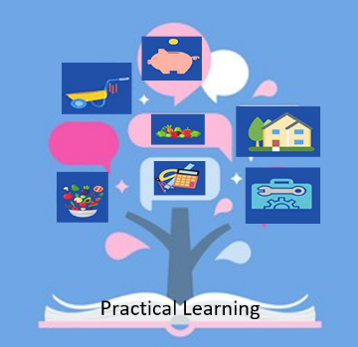  Practical Learning  Room 12 |  | Practical Learning  Room 12 | Practical Learning  Room 12 |  |   British Values/  Current affairs |   Creative Studies  Room 5 or PA | Creative Studies  Room 5 or PA
Wednesday |   Numeracy | English  Room 12 |  | Maths  Room 12 |   PE  Hall |  | 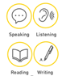  Literacy |   Science  Room 12 |   Beliefs & Values  Room 12
Thursday | Literacy |   P4A  Room 12 |  | P4A  Room 12 | P4A  Room 12 |  | Numeracy | Maths  Room 12 | English  Room 12
Friday |   Pastoral | 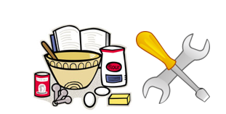  DT/FT  Room 8/9 |  | DT/FT  Room 8/9 |   ICT  ICT Room |  |   Pastoral  Credits | PE  Hall |   Reward Time  Room 12

