YEAR 7 |  | Autumn | Spring | Summer
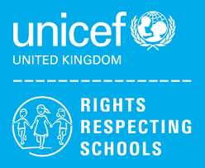 | Rights of the Child | Article 29 (goals of education) Education must develop every child’s personality, talents and abilities to the full. It must encourage the child’s respect for human rights, as well as respect for their parents, their own and other cultures, and the environment. | Article 29 (goals of education) Education must develop every child’s personality, talents and abilities to the full. It must encourage the child’s respect for human rights, as well as respect for their parents, their own and other cultures, and the environment. | Article 29 (goals of education) Education must develop every child’s personality, talents and abilities to the full. It must encourage the child’s respect for human rights, as well as respect for their parents, their own and other cultures, and the environment.
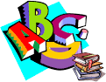 | English | Biographies – Boy by Roald Dahl  Autobiographical Writing | Speaking and Listening – Group Discussion  Modern Novel – Boy at the back of the class | Spelling, Punctuation and Grammar  The Savage
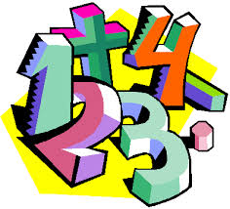 | Maths | Place Value (7CB) (7SA) (7LA)  Addition and Subtraction (7CB) (7SA) (7LA)  Multiplication & Division (7SA)  Geometry (Shape) (7CB) (7LA) | Addition & Subtraction (7LA)  Length & Height (7CB) (7LA)  Mass, capacity and temperature (7CB)  Money (7CB)  Multiplication & division (7CB) (7SA)  Length & Perimeter (7SA)  Fractions (7SA)  Mass & capacity (7SA)  Place value (7LA)  Mass & Volume (7LA) | Multiplication & Division (7LA)  Fractions (7CB) (7SA) (7LA)  Geometry (Position & Direction) (7CB) (7LA)  Time (7CB) (7SA) (7LA)  Statistics (7CB) (7SA)  Money (7SA) (7LA)  Shape (7SA)  Place Value (7LA)
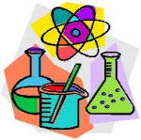 | Science | Cells and Organisation  States of Matter and Separating Mixtures | Energy Changes and Transfers  Reproduction | Atoms and Periodic Table  Forces
 | Computing/ICT | Powerpoint Presentations: Endangered Animals,  E-Safety / Cyberbullying | Scratch Programming  Desktop Publishing – Creating a leaflet | Spreadsheet Modelling  Using Datasets
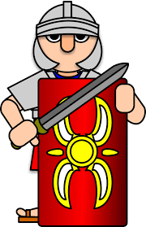 | The Wider World | History – The Normans (7LA) (7SA) (7CB)  Geography- Tectonics (7LA) (7CB)  MFL- A New Start, Calendar & Celebrations (7SA) | Geography – Rivers (7LA) (7CB)  - Tectonics (7SA)  MFL – A New Start, Calendar & Celebrations (7LA) (7CB)  - Animals, Using Numbers, Fruit and Veg, Going on a Picnic (7SA) | History – The Tudors (7LA) (7SA) (7CB)  Geography – Rivers (7SA)  MFL – Animals, Using Numbers, Fruit and Veg, Going on a Picnic (7LA) (7CB)
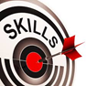 | Practical Learning | Lift Off  Activity programme to support transition from primary to secondary school. Students to develop skills in  - Awareness  - Aspiration  - Attainment  Life Skills Challenges – Literacy, Numeracy & Digital Skills  Practical Literacy Skills – Writing  Practical Literacy Skills – Reading  Practical Numeracy Skills – Time  Practical Numeracy Skills – Measurement  Digital Skills | Global Learning  - Current Affairs  - Martin Luther King Day  - Holocaust Memorial Day  - Children’s Mental Health Day  - Chinese New Year  LOTC – Local Area  - Walk to Local Shop  - Walk around local area  - Visit to Victoria Park  - Visit to the Hive Leisure Centre to survey facilities  - The Hive Bowling | Forest School – Beginner  - Introduction to health and safety  - Woodcraft  - Shelter building  - Fire  - Nature  - Ropes  Forest School – Beginner Advanced  - Woodcraft  - Shelter building  - Fire  - Nature  - Ropes
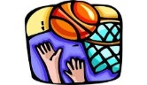 | P.E. | Basketball  Gymnastics  Badminton  Boccia | Health Related Fitness  Trampolining  Hockey  Cricket | Rounders  Athletics  Walking  Cycling
 | Design Technology | Health & Safety  Plastics  (7A)  Metals  (7A) | Wood  (7A)  Health & Safety  Plastics  (7B) | Metals  (7B)  Wood  (7B)
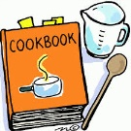 | Food Technology | Introduction to the kitchen  &  baking  Health & Safety  Religious Festivals | Food nutrition & Independent cooking  Introduction to the kitchen & baking | Food nutrition & Independent cooking  Health & Safety  Religious Festivals
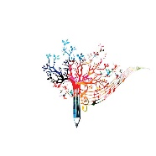 | Creative Studies  Art | Elements of Art | Collage  Roman Mosaics | Fauvism
 | Creative Studies Music | Listening Skills & Rhythm (Mamma Mia) | Interpreting Music | Exploring Instruments of the Orchestra
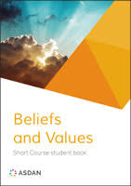 | Beliefs and Values | Christianity: God and Humanism  Caused or Chance? Ideas about the origins of the universe.  Judaism  How do Jewish holy days remind adherents of their faith? | Christianity: Jesus  Faith and Justice – How should we treat our ‘neighbours’?  Islam  What does belonging mean to a young Muslim in the UK? | Christianity: Church  What is the church?  Hindu Dharma  What might Hindus learn through celebrating festivals?
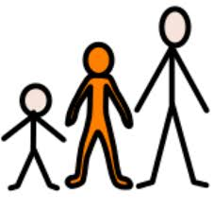 | Preparing for Adulthood | Community Inclusion  Relationships – (Exploring family life, understanding different families)  Rights and Responsibilities in the community  Ashley Values / Respect for Others  Understanding Emotions  Independent Living  Personal Appearance and Personal Hygiene / Emergency and Safety Skills  Good Health  Alert Programme – How does my engine run?  Managing my emotions | Community Inclusion  Relationships – Self-esteem, romance and friendship  Employment / Careers  Introduction to Careers – Raising awareness of the variety of jobs all around us / Employer Talks (The range of jobs available in the NHS / Guess the employer)  Independent Living  Housekeeping – Washing Dishes / Using a toaster and kettle / Setting a table / Making a bed / Waste disposal / Name and address / Using a post office  Community Inclusion  Diversity, Prejudice and Bullying and the impact on communities | Good Health  SRE – Managing puberty and the issue of unwanted contact / Consent  Medication and Drugs – Difference between drugs and medication / taking medication / How alcohol, drugs and tobacco can be dangerous to health  Independent Living  Food Management – Types of meals / Ordering Food / Table manners  Transport – Road Safety / Types of transport

