Student Code of Conduct
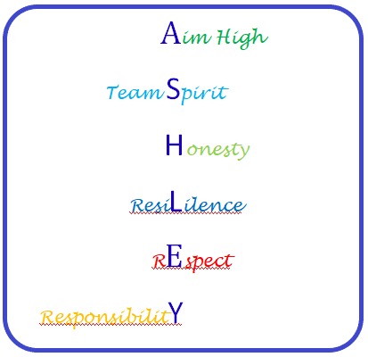

Students, please read this document and sign below
As a student I will –
- Arrive at school and to lessons every day, on time and ready to learn
- Try my best to do my work, ask for help if I need it and accept support and advice from staff
- Wear the correct school uniform
- Follow school rules (see below) and staff instructions
- Look after school equipment, and show respect for the school environment and local community
- Be a champion of the 6 Ashley High School core values –

- Aim High
- Team Spirit
- Honesty
- Resilience
- Respect
- Responsibility

Ashley High School Rules

- AIM HIGH
I will work hard, try my best and challenge myself, even when things seem difficult. I will try to work as independently as possible.

- TEAM SPIRIT
I will work together with staff and other students to encourage each other and do the very best we can as a group.

- HONESTY
I will tell the truth, even if I make mistakes. That way I can be trusted and I can trust other people.

- RESILIENCE
I will learn to cope with things if they go wrong and understand that it is OK to make mistakes, as long as I keep trying my hardest.

- RESPECT
I will behave and communicate in a kind way and treat everyone as equals, making sure my words and actions do not upset or hurt others, or stop them from learning.

- RESPONSIBILITY
I will be a positive role model to other people and look after them. I will make good choices and accept the results of my actions.

Signed __________________________ (Student) Date _____________________

Parent/Carer Code of Conduct

Parents/Carers, please read this document and sign below
As a parents/carers we will –
- Ensure that our child attends school regularly, on time, properly equipped and in correct school uniform
- Attend any relevant meetings or school appointments in order to achieve the best outcomes for our child
- Read and stay up to date with the school’s policies and information
- Treat all members of the school community with care and respect (including social media communications)
- Read any communications sent home by the school and respond promptly where necessary
- Support the 6 Ashley High School core values of -

- Aim High
- Team Spirit
- Honesty
- Resilience
- Respect
- Responsibility

- AIM HIGH
We will promote our child’s development and education by encouraging them to have a positive work ethic and supporting them to complete all homework tasks, enabling them to reach their full potential.

- TEAM SPIRIT
We will work in partnership with the school to celebrate and reward our child’s achievements and support them as needed.

- HONESTY
We will communicate openly and clearly with school staff in order to best support our child’s needs.

- RESILIENCE
We will focus on the positive elements of students school life, helping our child to become more resilient and to cope with difficult or new learning experiences appropriately.

- RESPECT
We will behave and communicate in a kind, appropriate and tolerant manner, making sure we recognise others opinions, needs and viewpoints.

- RESPONSIBILITY
We will act as positive role models to our child, ensuring they are aware of, and observe the 6 Ashley High School core values.

Childs Name ________________
Signed __________________________ (Parent/Carer) Date _____________________

Staff Code of Conduct

Staff, please read this document and sign below
As a member of staff I will –
- Support your child’s wellbeing and safety by providing a safe, supportive
and caring environment
- Communicate in a timely manner about any problems or concerns which are affecting your child’s work or behaviour
- Provide a balanced curriculum tailored to the needs of Ashley High School students
- Promote high standards of behavior, and outline clear expectations in our behaviour policy so we can maintain a safe environment for all children
- Set homework that supports the delivery of the curriculum and provide feedback where appropriate
- Offer opportunities for parents and carers to get involved in school life
- Keep you informed about school matters in general, through the newsletter and your child’s progress in particular through our reporting and communication systems
- All staff will promote the 6 Ashley High School core values of –

- Aim High
- Team Spirit
- Honesty
- Resilience
- Respect
- Responsibility

- AIM HIGH
We will have high expectations of all students and provide relevant challenge in all areas of school life, enabling them to reach their full potential.

- TEAM SPIRIT
We will work collaboratively and enthusiastically with all stakeholders to provide both students and parents/carers with a sense of belonging and positive support. We will celebrate and reward your child’s success.

- HONESTY
We will behave and communicate both openly and transparently, enabling us to develop positive and trusting relationships with all stakeholders.

- RESILIENCE
We will teach and demonstrate strategies that aid students in reacting to, and coping with, situations they find difficult or challenging.

- RESPECT
I will behave and communicate in a kind, appropriate and tolerant manner, making sure we recognise others opinions, needs and viewpoints.

- RESPONSIBILITY
We will act as positive role models and do all we can to provide the holistic care and support your child needs to develop academically, socially, personally and emotionally.

Signed __________________________ (Staff Member) Date _____________________

