YEAR 7 |  | Summer
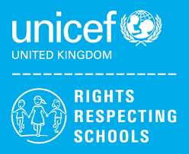 | Rights of the Child | Article 29 (goals of education) Education must develop every child’s personality, talents and abilities to the full. It must encourage the child’s respect for human rights, as well as respect for their parents, their own and other cultures, and the environment.
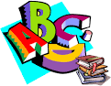 | English | Writing: Transactional and Creative Writing  7SA- Narrative writing, short stories, character profiles  7LA- Narrative writing, short stories, character profiles
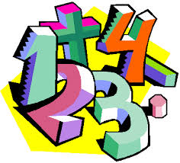 | Maths | 7SA: Place Value, Fractions, Decimals, Money, Time, Shape and Measures  7LA:Direction and position, data handling, pictograms and bar charts
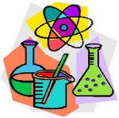 | Science | 7SA: Forces and Energy Transfers
 | Computing/ICT | Spreadsheet Modelling,  Using Datasets
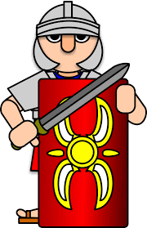 | Wider World | History- Tudors and Stuarts  Geography- Map Skills  German- Colours and numbers
 | Practical Learning | Gardening- Planting out, Harvesting  Forest School- Shelters, Nature  Global Learning- Outdoor Classroom Day, Hedgehog Awareness, World Ocean Day, Day of the African Child, International Day of Yoga  Life Skills- First Aid- Bleeding  Practical Numeracy- plan a simple budget, How can I pay for things, Keep my money safe, How can I use A Bank Account  Practical Literacy- Literacy Board games. Mirror- Jeannie Browne
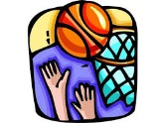 | P.E. | Rounders, Tag Rugby, Athletics, Tennis
 | Design Tech | Coat hook, Ball bearing game
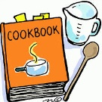 | Food Tech | 7LA – Healthy Eating/Baking
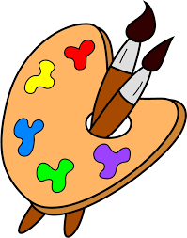 | Creative Studies Art | Fauvism
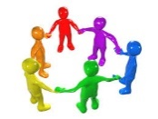 | P4A | Good Health – managing puberty + consent  Medication & Drugs  Types of Transport  Housekeeping
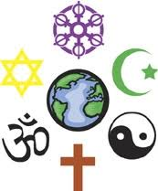 | RE | Islam: Ramadan
 | Creative Studies Music | The Orchestra

