YEAR 12/13 |  | Autumn | Spring | Summer
 | Rights of the Child | Article 29 (goals of education) Education must develop every child’s personality, talents and abilities to the full. It must encourage the child’s respect for human rights, as well as respect for their parents, their own and other cultures, and the environment. | Article 29 (goals of education) Education must develop every child’s personality, talents and abilities to the full. It must encourage the child’s respect for human rights, as well as respect for their parents, their own and other cultures, and the environment. | Article 29 (goals of education) Education must develop every child’s personality, talents and abilities to the full. It must encourage the child’s respect for human rights, as well as respect for their parents, their own and other cultures, and the environment.
 | English | Functional Skills English  Non-Fiction Writing  Shorter Writing task  Composition & SPaG  Longer Writing task  Composition & SPaG | Speaking and Listening –  Individual presentation  Group discussion  Reading –  Reading and understanding non-fiction texts  Single source questions | Reading –  Reading and understanding non-fiction texts  Multiple source questions  Exam Skills –  Understanding Instructions, Time management, managing exam stress etc
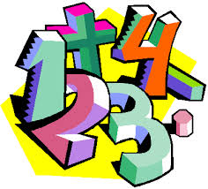 | Maths | Year 12 Entry 3  Data Handling – recording information  Data Handling – extracting information  Year 12 Level 1  Understanding and Using 2D shapes  Understanding Numbers  Year 13 Level 1  Understanding and using 2D shapes  Understanding Numbers | Year 12 Entry 3  Data – continued  Number Skills  Year 12 Level 1  Understanding and Using Fractions  Using Calculations: Addition and Subtraction of Whole Numbers  Year 13 Level 1  Understanding and Using Fractions  Using Calculations: Addition and Subtraction of Whole Numbers | Year 12 Entry 3  Applying Fraction skills  Coursework completion  Year 12 Level 1  Understanding Volume  Probability  Year 13 Level 1  Understanding Volume  Probability
 | Computing/ICT | E3 Certificate – Spreadsheet Software / Database Software / Desktop Publishing Software  Level 1 Award – Word Processing Software / Presentation Software | E3 Certificate – Desktop Publishing Software / Using Email  Level 1 Award – Presentation Software / Spreadsheet Software / Database Software | E3 Certificate – Using Email / Internet Fundamentals  Level 1 Award – Database Software / Desktop Publishing Software
 | Employability | Year 12  Developing Own Interpersonal Skills  Year 13  Health, Safety and First Aid at Work | Year 12  Preparation for Work  Year 13  Using Email in the Workplace | Year 12  Customer Service  Year 13  Understanding the Office Environment
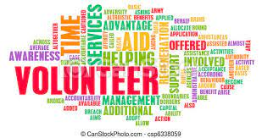 | Vocational Studies | Year 12 Core  Developing a Personal Progression Plan  Sector  Growing Plants  Contributing to your Community  Serving Food and Drink | Year 12 Core  Being Organised  Year 13 Core  Working as a Team  Sector  Growing Plants  Contributing to Running an Event  Preparing and Cooking Food | Year 12 Core  Researching a Topic  Sector  Animal Care  Contributing to the Community  Preparing and Cooking Food
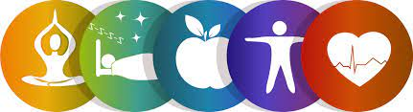 | Youth Award | Year 12  Module 1 – Communication  Module 2 – My Community  Module 3 – Sport & Leisure  Module 4 – Independent Living  Module 5 – My Environment  Module 6 – Number Handling  Module 7 – Health and Wellbeing  Module 11 – Expressive Arts  Year 13  Individual tasks chosen from the following modules –  Module 1 – Communication  Module 2 – My Community  Module 3 – Sport & Leisure  Module 4 – Independent Living  Module 5 – My Environment  Module 6 – Number Handling  Module 7 – Health & Wellbeing  Module 8 – World of Work  Module 9 – Science & Technology  Module 10 – The Wider World  Module 11 – Expressive Arts  Module 12 – Beliefs & Values | Year 12  Module 1 – Communication  Module 2 – My Community  Module 3 – Sport & Leisure  Module 4 – Independent Living  Module 6 – Number Handling  Module 7 – Health and Wellbeing  Module 8 – World of Work  Year 13  Individual tasks chosen from the following modules –  Module 1 – Communication  Module 2 – My Community  Module 3 – Sport & Leisure  Module 4 – Independent Living  Module 5 – My Environment  Module 6 – Number Handling  Module 7 – Health & Wellbeing  Module 8 – World of Work  Module 9 – Science & Technology  Module 10 – The Wider World  Module 11 – Expressive Arts  Module 12 – Beliefs & Values | Year 12  Module 1 – Communication  Module 3 – Sport & Leisure  Module 4 – Independent Living  Module 5 – My Environment  Module 6 – Number Handling  Module 7 – Health & Wellbeing  Module 8 – World of Work  Module 12 – Beliefs & Values  Year 13  Individual tasks chosen from the following modules –  Module 1 – Communication  Module 2 – My Community  Module 3 – Sport & Leisure  Module 4 – Independent Living  Module 5 – My Environment  Module 6 – Number Handling  Module 7 – Health & Wellbeing  Module 8 – World of Work  Module 9 – Science & Technology  Module 10 – The Wider World  Module 11 – Expressive Arts  Module 12 – Beliefs & Values
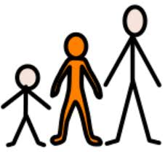 | Preparing for Adulthood | Year 12 Independent Living  Personal Finance – Money Works delivered by MyBnk  Independent Living Skills  Year 12 Community Inclusion  CEASE Training – Delivered by Remedi  Peer Pressure – AWF Life Share  Year 12 Good Health  SRE  Drugs, Smoking, Alcohol  Year 13 Independent Living  Travelling independently / Visit to Liverpool Airport  Year 13 Community Inclusion  The criminal justice system  Year 13 Employment  Individual Work Experience Placements | Year 12 Employment  Vocational Taster Sessions – delivered at The Bridge  Individual Work Experience Placements  Year 13 Community Inclusion  Social Media / Online Fraud  Extremism / Radicalisation | Year 12 Employment  Group Workplace Taster Sessions  Year 12 Community Inclusion  Tolerance and Diversity  Year 13 Good Health  Mental Health  5 Steps to Wellbeing  Mindfulness  Year 13 Employment  Volunteering
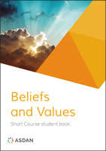 | Beliefs and Values | Peace and Conflict | Religion, Relationships and Family Life  Religion and Life | Religion and Social Justice

