YEAR 7 |  | Autumn | Spring | Summer
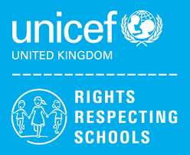 | Rights of the Child | Article 29 (goals of education) Education must develop every child’s personality, talents and abilities to the full. It must encourage the child’s respect for human rights, as well as respect for their parents, their own and other cultures, and the environment. | Article 29 (goals of education) Education must develop every child’s personality, talents and abilities to the full. It must encourage the child’s respect for human rights, as well as respect for their parents, their own and other cultures, and the environment. | Article 29 (goals of education) Education must develop every child’s personality, talents and abilities to the full. It must encourage the child’s respect for human rights, as well as respect for their parents, their own and other cultures, and the environment.
 | English | Biographies – Boy by Roald Dahl  Autobiographical Writing | Speaking and Listening – Group Discussion  Modern Novel – Boy at the back of the class | Spelling, Punctuation and Grammar  The Savage
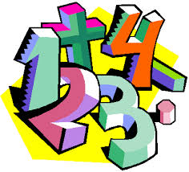 | Maths | Place Value, Addition and Subtraction, Geometry (Shape) | Addition & Subtraction, Place Value, Length & Height, Weight & Volume, Money, Time | Multiplication & Division, Fractions, Geometry (Position & Direction), Place Value
 | Science | Cells and Organisation  States of Matter and Separating Mixtures | Energy Changes and Transfers  Reproduction | Atoms and Periodic Table  Forces
 | Computing/ICT | Powerpoint Presentations: Endangered Animals,  E-Safety / Cyberbullying | Scratch Programming  Desktop Publishing | Spreadsheet Modelling  Using Datasets
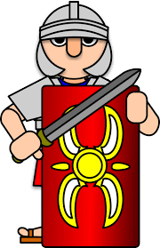 | The Wider World | History – The Romans  Geography- Tectonics  MFL- A new start (Greetings, Feelings, Numbers, Colours, Days and Months, Christmas) | History – The Normans  Geography – Settlements  MFL – Animal nouns, singular and plural, Numbers to 15, Age, Dates, Easter | History – The Tudors  Geography – Map Skills  MFL – Fruit and Veg, Nouns, Board Game, Flags, Explore Germany
 | Practical Learning | My Interests  My hobbies & interests  LOTC – School Grounds  Treasure Hunt  Managing My Money | Global Learning  Current Affairs  Martin Luther King Day  Holocaust Memorial Day  Children’s Mental Health Day  Chinese New Year  LOTC  Visit to the Local Shop  Visit to Ditton Park | Forest School
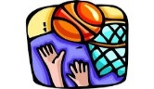 | P.E. | Basketball  Gymnastics  Badminton  Boccia | Health Related Fitness  Trampolining  Hockey  Cricket | Rounders  Athletics  Walking  Cycling
 | Design Tech | Health & Safety  Plastics  Metals  (7SA) | Wood (7SA)  Health & Safety  Plastics  (7LA) | Metals  Wood  (7LA)
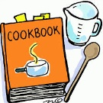 | Food Tech | Introduction to the kitchen  &  baking  Health & Safety  Religious Festivals  (7LA) | Introduction to the kitchen & baking  (7LA)  Introduction to the kitchen & baking  (7SA) | Introduction to the kitchen & baking  Health & Safety  Religious Festivals  (7SA)
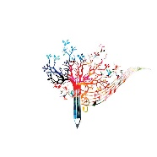 | Creative Studies  Art | Elements of Art | Collage  Roman Mosaics | Fauvism
 | Creative Studies Music | Listening Skills & Rhythm | Interpreting Music | Exploring Instruments of the Orchestra
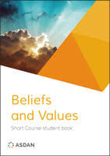 | Beliefs and Values | Christianity (God)  How and why might Christians use the Bible? | Hindu Dharma  What might a Hindu learn through celebrating Diwali?  Christianity (Jesus)  Is sacrifice an important part of religious life? | Islam  Why do Muslims fast during Ramadan?  Christianity (Church)  What does ‘love your neighbour’ really mean?
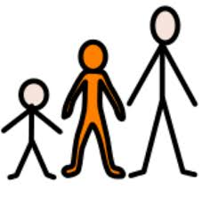 | Preparing for Adulthood | Community Inclusion  Relationships – (Exploring family life, understanding different families)  Rights and Responsibilities in the community  Ashley Values / Respect for Others  Independent Living  Personal Appearance and Personal Hygiene / Emergency and Safety Skills  Good Health  Alert Programme – How does my engine run?  Managing my emotions | Community Inclusion  Relationships – Self-esteem, romance and friendship  Employment / Careers  Introduction to Careers – Raising awareness of the variety of jobs all around us / Employer Talks (The range of jobs available in the NHS / Guess the employer)  Independent Living  Housekeeping – Washing Dishes / Using a toaster and kettle / Setting a table / Making a bed / Waste disposal / Name and address / Using a post office  Community Inclusion  Diversity, Prejudice and Bullying and the impact on communities | Good Health  SRE – Managing puberty and the issue of unwanted contact / Consent  Medication and Drugs – Difference between drugs and medication / taking medication / How alcohol, drugs and tobacco can be dangerous to health  Independent Living  Food Management – Types of meals / Ordering Food / Table manners  Transport – Road Safety / Types of transport

