YEAR 9 |  | Summer
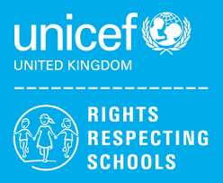 | Rights of the Child | Article 29 (goals of education) Education must develop every child’s personality, talents and abilities to the full. It must encourage the child’s respect for human rights, as well as respect for their parents, their own and other cultures, and the environment.
 | English | 9AK, 9JO, 9KD Shakespeare: Romeo & Juliet
 | Maths | 9AK – Number, Algebra, Ratio & Proportion, Geometry & Measures, Probability, Statistics  9JO - Measures, Statistics, Number, Geometry  9KD – Measures, Number, Geometry
 | Science | GCSE: Bonding, Electricity  ELC Energy Forces and structure of matter
 | Computing/ICT | Spreadsheet Modelling – Harry Plotter, Scratch Programming Software
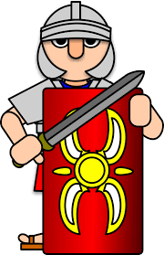 | History | Halton Through History  (Local History unit)
 | MFL | French: All About Me, Family
 | Practical Learning | Rivers, Weathering and Erosion, Geography investigations  First Aid  Interpersonal Skills
 | P.E. | Tag Rugby, Athletics,  Rounders, Tennis
 | Design Tech | Mechanical toy, Jigsaw puzzle
 | Food Tech | 9KD– Individual Cooking Skills / Food Poisoning
 | Art | Ceramics Project
 | PHSCE | Health and Wellbeing – managing peer pressure  Living in the wider world, Career Talk
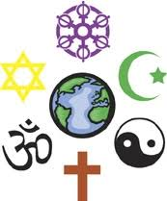 | RE | Islam
 | Music | Popular music  Musical vocabulary

