YEAR 8 |  | Summer
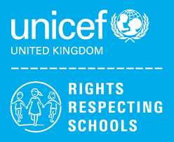 | Rights of the Child | Article 29 (goals of education) Education must develop every child’s personality, talents and abilities to the full. It must encourage the child’s respect for human rights, as well as respect for their parents, their own and other cultures, and the environment.
 | English | 8MS and 8JF (L) - Non-Fiction incl. persuasive writing, instructions, information texts  8JF (H) Transactional Writing
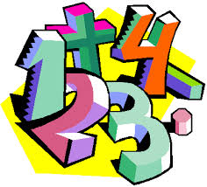 | Maths | 8JF (h) – Sequences, Fractions & Percentages, Probability  8JF (l) - Decimals, money, time, shape, statistics, position and direction  8MS - Measurement: Money & Time, Number: Fractions, Geometry: Shape, Statistics
 | Science | Rocks, Earth & Space, Breathing & Respiration, Unicellular Organisms
 | Computing/ICT | Spreadsheet Modelling – Costing a real-life business (Snack Bar), Data Handling – Super Heroes
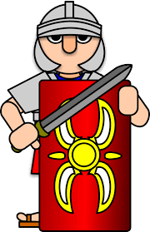 | History | The Industrial Revolution
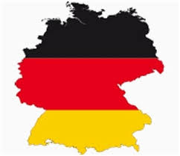 | MFL | German:  On Our Travels/Freizeit (Freetime)/Stadt und Land (Urban and Countryside)
 | Practical Learning | Tectonics and Ecosystems  Transport  Knowledge of Community Services  Legal Issues  Emergency and Safety Skills
 | P.E. | Rounders, Tag rugby, Athletics, Tennis
 | Design Tech | Desk tidy, Structures
 | Food Tech | Local Food Establishments/ Healthy Living
 | Art | Stained Glass Windows
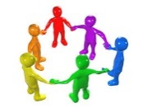 | PHSCE | Health and Wellbeing – managing change and loss  Living in the wider world – Tackling discrimination  Careers – STEM Employer Talk
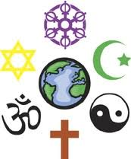 | RE | Christianity  Why do people choose to believe?  Ultimate Questions.
 | Music | Variations In music
 | Skills Builder | 8MS- Staying Positive  8JF – Staying Positive

