YEAR 9 |  | Autumn
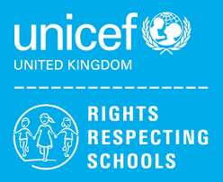 | Rights of the Child | Article 29 (goals of education) Education must develop every child’s personality, talents and abilities to the full. It must encourage the child’s respect for human rights, as well as respect for their parents, their own and other cultures, and the environment.
 | English | All Year 9 – A Christmas Carol
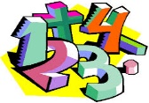 | Maths | 9KD (H) - Number Calculations, Sequences and Equations, Statistics, Fractions, Decimals and Percentages  9KD (L) - Place Value, Addition & Subtraction, Multiplication & Division, Fractions  9JO - Place Value, Addition & Subtraction, Measurement Area, Multiplication & Division
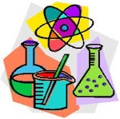 | Science | Inheritance and Evolution  Ecosystems and Interdependence
 | Computing/ICT | Hardware/Software, Multimedia ICT Presentations  Scratch Programming
 | History | WW2 and the Holocaust
 | MFL | Describing your home
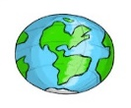 | Practical Learning | Geography (Japan, climate change)  Independent Living (Health, Looking after pets, cleaning my own space, money management)
 | P.E. | Basketball / Teambuilding and Problem solving  Dodgeball / Badminton
 | Design Tech | Mechanisms – Cams  CAD/CAM- Jigsaw
 | Food Tech | Individual Cooking Skills  Nutrition  &  Health
 | Art | African Art - Masks
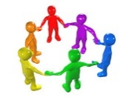 | PHSCE | Health & Wellbeing  Peer pressure, assertiveness and risk, gang crime  Living in the Wider World  Understanding careers and future aspirations
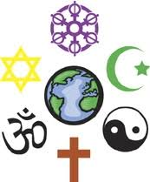 | RE | Christianity and Hinduism
 | Music | Pop/Soul music, Ukulele practical

