YEAR 9 |  | Spring
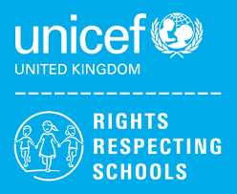 | Rights of the Child | Article 29 (goals of education) Education must develop every child’s personality, talents and abilities to the full. It must encourage the child’s respect for human rights, as well as respect for their parents, their own and other cultures, and the environment.
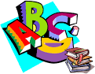 | English | Year 9 – Poetry & Historical Speeches
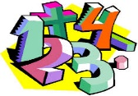 | Maths | 9AK – Number, Algebra, Geometry & Measures, Ratio & Proportion, Probability, Statistics  9JO – Fractions, Multiply & Divide, Decimals & Percentages  9KD – Multiply & Divide, Length & Perimeter, Fractions
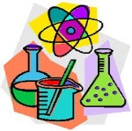 | Science | GCSE: Energy, Organisation  9KD ELC: Element mixtures and compounds
 | Computing/ICT | Powerpoint Presentations – The Loch Ness Monster  Databases – Murder Mountain Mystery
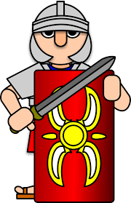 | History | 9KD The Civil Rights Movement  (Martin Luther King)
 | MFL | French: My Classroom/My House
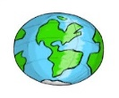 | Practical Learning | Environmental Issues  Big Bird School Watch  Personal appearance, washing and drying clothes  Maps and timetables, using Google maps, planning meals  Wonky Garden Project – 5 weeks
 | P.E. | Health Related Fitness, Hockey, Cricket, Rebound Therapy/Trampolining
 | Design Tech | Mechanical toy  Jigsaw
 | Food Tech | Home Cooking  Fast food Project
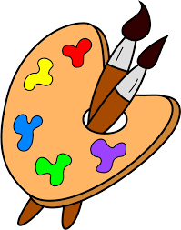 | Art | Architecture
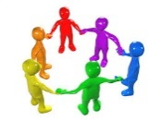 | PHSCE | Relationships – managing conflict, staying safe  Relationships – Tackling discrimination  Careers – Choosing options
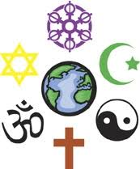 | RE | How can we make a difference? Bible Stories
 | Music | Rock Anthems

