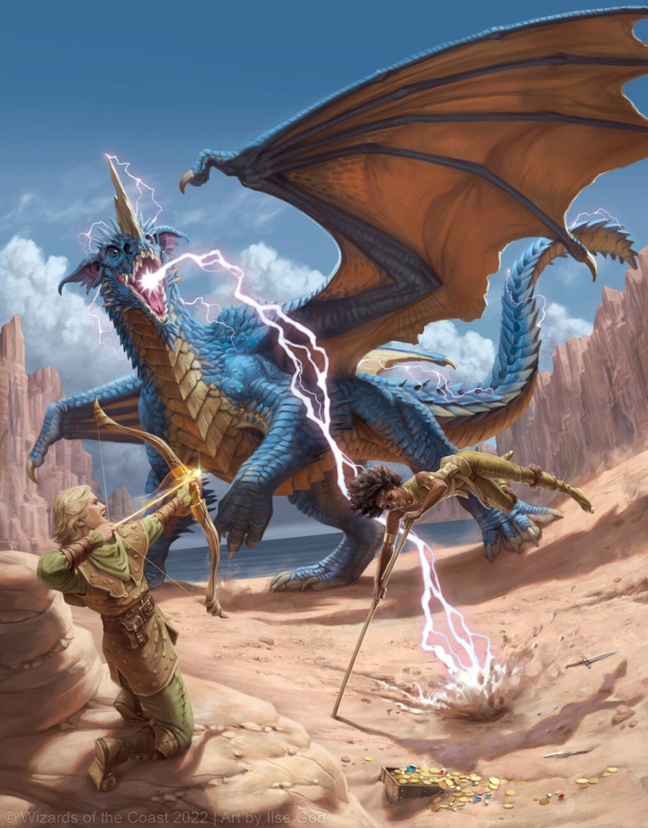  - dungeons & dragons club  Every Wednesday  An introduction to D&D from 2nd Nov – 30th Nov  Ever wanted to learn how to play Dungeons & Dragons?  Maybe you are an experienced player in search of a new group?  Come and join us, no matter what your level, and see how we roll!  Contact JANE LUNT at janelunt76@outlook.com  or CHRIS MOSS at krys247uk@gmail.com  Equipment provided by | ADVENTURERS WANTED!  ____  NO EXPERIENCE REQUIRED!  ____  EXPLORE STRANGE NEW WORLDS!  ____  BEST THE MIGHTIEST FOES!  ____  HAVE FUN WITH YOUR FRIENDS!  ASHLEy HIGH SCHOOL  SCHOOL COUNCIL CHAMBER  15:00 – 16:00

