My name is Carolyn Olleveant I am the school nurse for Ashley High School.
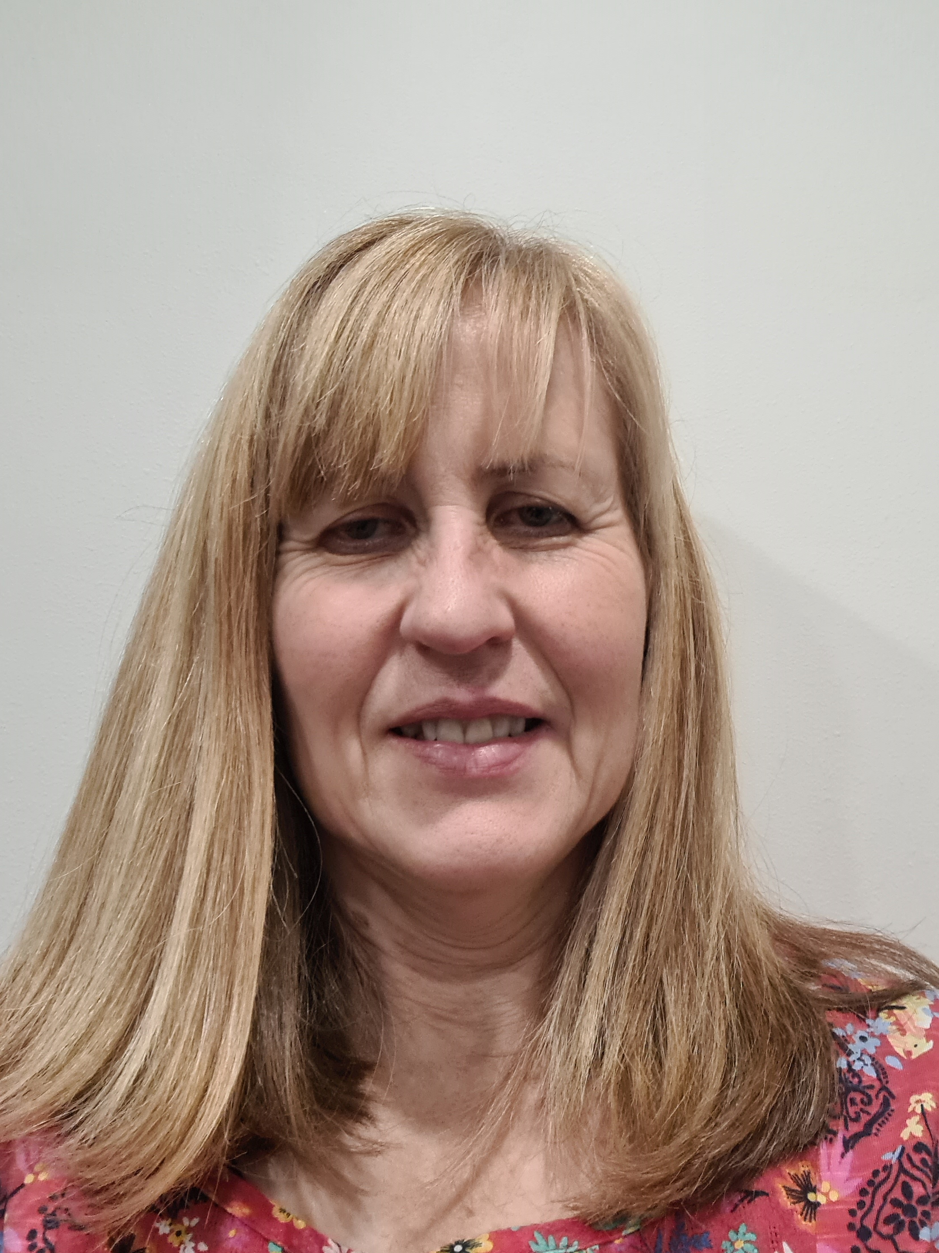
I hold a drop-in on a Thursday morning in school for students. Parent/carers I can be contacted on the following numbers (please leave a message or text).
Mobile: 07876843308
Office: 01928 593056
Parents/Carers these are some examples of what I can support with - referrals, monitoring physical health, sleep, behaviour, diet, oral health.
If there is anything else, please contact me.

