 | Literacy/  Numeracy  Time  9:00 – 9:30 | Lesson 1  9:30 – 10:20 | Timetable 11SC 25/26  Break  10:20-10:35 | Lesson 2  10:35 – 11:30 | Lesson 3  11:30 – 12:20 | Lunch  12:20 –12:55 | Lesson 4  12:55 – 1:20 | Lesson 5  1:20 – 2:10 | Lesson 6  2:10 – 3:00
Monday | 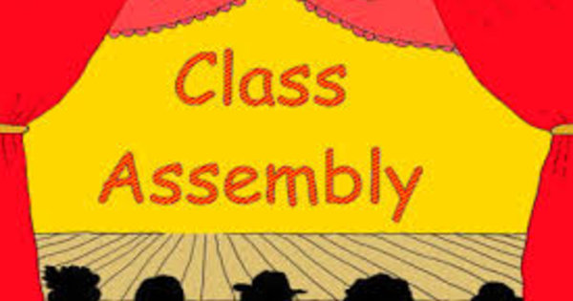 | 11SC/11GG    PE |  | 11SC/11GG  PE |   Science  Room 4 |  |   Numeracy |   Maths  Room 18 | 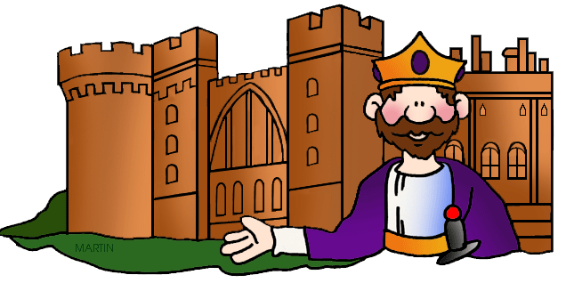  History  Room 12
Tuesday | 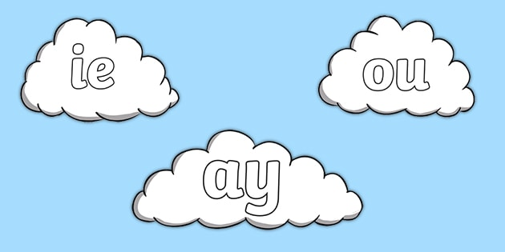  Literacy | 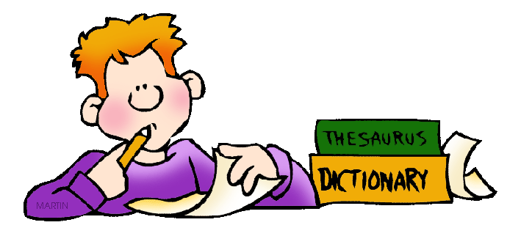  English  Room 15 |  | Construction/    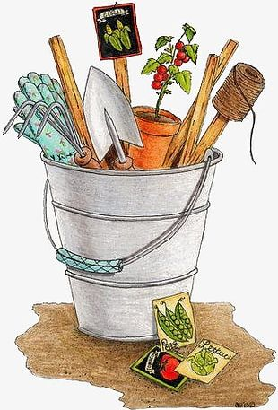  Gardening  Art/DT | Construction/  Gardening  Art/DT |  | Current Affairs/British Values | History  Room 1 | 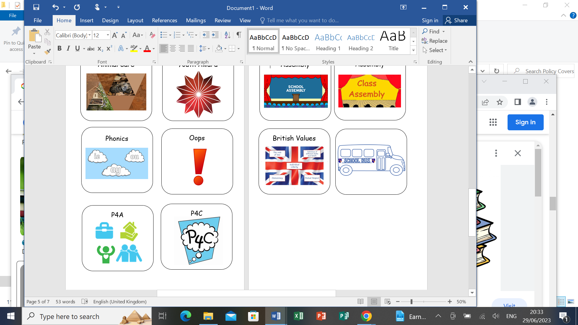  RSE  Room 17
Wednesday | 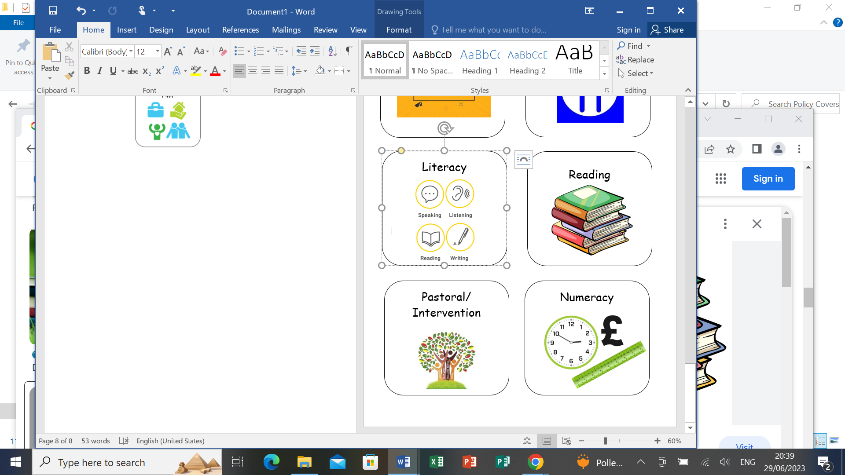  Numeracy | English  Room 15 |  | Maths  Room 18 | History  Room 20 |  | Literacy | Science  Room 4 | Science  Room 4
Thursday |   RE | Maths  Room 18 |  | English  Room 15 | Science  Room 4 |  | Numeracy |   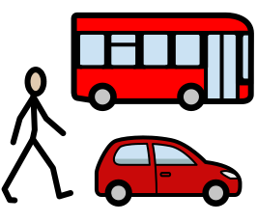  Ind. Living/Travel  Room 20/2 | Ind. Living/Travel  Room 20/2
Friday |   Pastoral |   ICT |  | ICT | English  Room 15 |  | Pastoral/Credits | Maths  Room 18 |   Room 14

SC

