HAF CHRISTMAS HOLIDAY 2022 ACTIVITIES @ CHI COMMUNITY CAFÉ, Phoenix Park. Runcorn, WA7 2NY

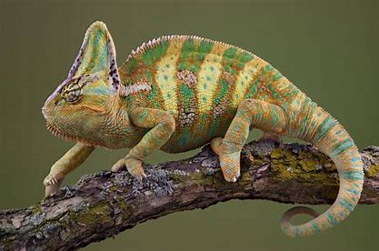

SAT 17TH DEC – CREEPY CRAWLIES & REPTILES with ANIMAL TEACH

12.00-2.00pm 1st session (F)
2.00-3.30pm 2nd session (SS)

SUN 18TH DEC – CREEPY CRAWLIES & REPTILES with ANIMAL TEACH

12.00-2.00pm 1st session (F)
2.00-3.30pm 2nd session (SS)

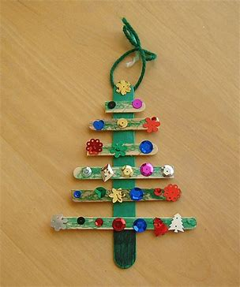

THURS 22nd DEC - XMAS CRAFTS & FILM with CRAFTY WELLBEING

11.00-12.30pm 1st session (F)
12.30-2.00pm 2nd session (SS)

THUR 29TH DEC – XMAS PARTY with ALADDIN’S CAVE ENTERTAINMENTS

11.00-12.30pm 1ST session (F)
12.30-2.00pm 2nd session (SS)

FREE MEAL & REFRESHMENTS FOR ALL CHILDREN (AGE 4-16 ONLY)
PLEASE CONTACT HAFatCHI@hotmail.com for booking information

