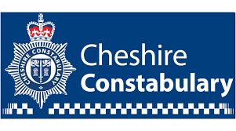
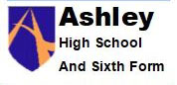

Dear Parent/Carer,

Our school is part of Operation Encompass which is a national scheme that operates jointly between schools and police forces.

Operation Encompass is the reporting to schools, prior to the start of the next school day, when a child or young person has experienced domestic abuse.

As a school we have ensured that two members of our staff, (Mike Jones and Jane Lunt) known as Key Adults, have been trained in the Operation Encompass procedures, allowing us to then use the information that has been shared, in confidence, to support the child/ren in our care.

The Domestic Abuse Act 2021 identifies children who experience domestic abuse as victims of domestic abuse in their own right.

We are keen to offer the best support possible to all our pupils and we believe this will be extremely beneficial for all those involved.

Signed

Diane Wilson

Head Teacher

