 | Literacy/  Numeracy  Time  9:00 – 9:30 | Lesson 1  9:30 – 10:20 | 9RF Timetable 2025-2026  Break  10:20 -10:35 | Lesson 2  10:35 – 11:30 | Lesson 3  11:30 – 12:20 | Lunch  12:20 – 12:55 | Lesson 4  12:55 – 1:20 | Lesson 5  1:20 – 2:10 | Lesson 6  2:10 – 3:00
Monday |   Hall |   Maths |  |   English |   PE |  | 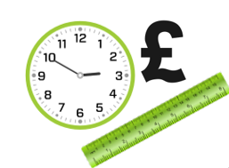    Numeracy |   Science |   ICT
Tuesday |   Guided Reading |   Practical Learning |  | Practical Learning | Practical Learning |  |   British Values/Current affairs |   Beliefs and values | English
Wednesday | Numeracy |   P4A |  | P4A | P4A |  |   Literacy |   Creative Studies | Creative Studies
Thursday | Literacy |   Wider World |  | Wider World | Maths |  | Numeracy |   FT/DT |   FT/DT
Friday |   Pastoral | Maths |  | English |   Science |  | Pastoral credits |   PE |   Reward Time

