YEAR 13 |  | Autumn
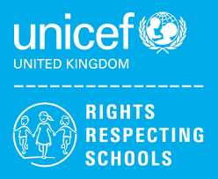 | Rights of the Child | Article 29 (goals of education) Education must develop every child’s personality, talents and abilities to the full. It must encourage the child’s respect for human rights, as well as respect for their parents, their own and other cultures, and the environment.
 | English | Year 13 – AQA Functional Skills English Level 2
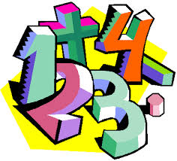 | Maths | Y13 Ascentis Maths Skills Level 1 – Understanding and Using 2D Shapes
 | Computing/ICT | Y12/13/14 (L) – WJEC Entry Pathways E3 Certificate – Spreadsheet Software, Database Software, Desktop Publishing Software  Y12/13/14 (H) – WJEC Entry Pathways E3 Certificate – Using Email, Internet Fundamentals  Y12/13/14 (H) - WJEC Entry Pathways Level 1 Award – Word Processing Software, Presentation Software
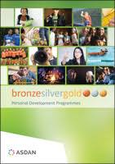 | CoPE/YAS | Young Health Champion  RSPH
 | Employability Level 1 Certificate | Health, Safety and First Aid at Work
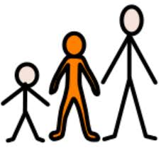 | Preparing for Adulthood | Travelling Independently  Individual Work Experience Placements
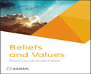 | Beliefs and Values | Peace and Conflict
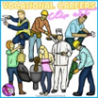 | Vocational Options  Entry 3 / Level 1 | Group 1 - Food & Drink Service  Group 2 – Contributing to your Community  Group 3 – Growing Plants
 | Sport | Gym workout

