YEAR 9 |  | Autumn | Spring | Summer
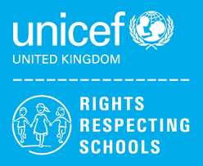 | Rights of the Child | Article 29 (goals of education) Education must develop every child’s personality, talents and abilities to the full. It must encourage the child’s respect for human rights, as well as respect for their parents, their own and other cultures, and the environment. | Article 29 (goals of education) Education must develop every child’s personality, talents and abilities to the full. It must encourage the child’s respect for human rights, as well as respect for their parents, their own and other cultures, and the environment. | Article 29 (goals of education) Education must develop every child’s personality, talents and abilities to the full. It must encourage the child’s respect for human rights, as well as respect for their parents, their own and other cultures, and the environment.
 | English | Classics – A Christmas Carol | Descriptive / Narrative Writing  Shakespeare – Romeo and Juliet | Contemporary Fiction – Refugee Boy / Terror Kid / Ghost Boys etc  Speaking & Listening
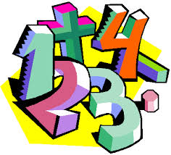 | Maths | Place value (9L) (9JO)  Addition & subtraction (9L) (9JO)  Geometry (shape) (9L)  Area (9JO)  Multiplication & division (9JO) | Length & height (9L)  Mass, capacity and temperature (9L)  Multiplication & division (9L) (9JO)  Length & perimeter (9JO)  Fractions (9JO)  Decimals (9JO)  Money (9L) | Fractions (9L)  Geometry (position & direction) (9L)  Time (9L) (9JO)  Decimals (9JO)  Money (9JO)  Shape (9JO)  Statistics (9L) (9JO)  Position and direction (9JO)
 | Science | Inheritance and Evolution  Ecosystems and Interdependence | Acids and Alkalis  Materials and Recycling | Motion and Pressure  Waves
 | Computing/ICT | Hardware / Software  Multimedia ICT Presentations  Scratch Programming Part 1 | Powerpoint Presentations  Databases – Murder Mountain Mystery | Spreadsheet Modelling  Scratch Programming Part 2
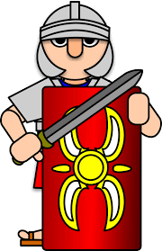   | The Wider World | Geography  Deserts / polar regions (9JO) (9L)  MFL  Talking About Us, School Subjects, In the City, Healthy Eating (9JO)  History  WW2 (9L) | History  WW2 (9JO)  Geography  Mega cities (9JO) (9L)  MFL  Talking About Us, School Subjects, In the City, Healthy Eating (9L) | MFL  Clothes, Out of This World, Everyday Life (9JO) (9L)  History  Local History Study – Halton through time (9JO) (9L)
 | Practical Learning | Life Skills Challenges – Literacy, Numeracy & Digital Skills  Practical Literacy Skills – Writing  Practical Literacy Skills – Reading  Practical Numeracy Skills – Time  Practical Numeracy Skills – Measurement  Digital Skills  Enterprise  Enterprise Project  - School Christmas Fayre  - Grangeway Hub Christmas Fayre | LOTC – A Journey Away  Train to Liverpool/Museum Visit  Local Farm  Canalside Walk  Formby Beach (Clean Up)  Residential (Catalyst Museum)  My Future  Vocational Tasters in  - Animal Care  - Catering  - Gardening  - Construction  - Creative Studies | Forest School  - Introduction to health and safety  - Woodcraft  - Shelter building  - Fire  - Nature  - Ropes
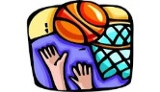 | P.E. | Basketball  Team building  Dodgeball  Badminton | Health Related Fitness  Trampolining  Hockey  Tag Rugby | Rounders  Athletics  Cycling  Walking
 | Design Technology | Mechanisms (Cams)  (9JO)  Jigsaw (CAD/CAM)  (9JO) | Electronics (SHG)  (9JO)  Mechanisms (Cams)  (9L) | Jigsaw (CAD/CAM)  (9L)  Electronics (SHG)  (9L)
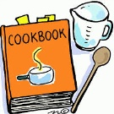 | Food Technology | Individual Cooking Skills  Nutrition & Health | Home Cooking  Fast Food Project  Individual Cooking Skills  Nutrition & Health | Individual Cooking Skills  Nutrition & Health  Home Cooking  Fast Food Project
 | Creative Studies  Art | African Art  2D Relief Masks & Printing | Hunderwasser | Ceramics
 | Creative Studies Music | African Drumming  (djembes) | Ukulele  Practical | Songs about Civil Rights
 | RE | Christianity(God)  What is faith?  Hindu Dharma  What matters in the journey of life? | Islam  What matters most in Islam?  Christianity (Jesus, Church, humanism)  How should we make moral decisions? | Sikh Dharma  Does religion encourage equality?  Big Question  Does religion matter in the 21st century?
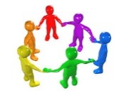 | RSE & Health Education | Health & Wellbeing  Peer pressure, assertiveness and risk, gang crime  Living in the Wider World  Understanding careers and future aspirations | Relationships  Managing conflict at home and staying safe  Careers Lesson/s  Choosing options – Introduction to the careers websites linking subjects to careers  Relationships  Tackling homophobia, transphobia and sexism  Careers Lesson/s  Using the Start website to view films on a variety of employers and job roles (1 lesson) | Health & Wellbeing  Managing peer pressure  Careers Lesson/s  Employer Talk  Living in the Wider World  Planning and carrying out an Enterprise Project
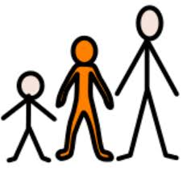 | Preparing for Adulthood | COMMUNITY INCLUSION  Peer pressure, assertiveness and risk, gang crime  EMPLOYMENT / CAREERS  Understanding Careers and Future Aspirations  Introduction to the Careers Service / JED  INDEPENDENT LIVING  Budgeting Skills  INDEPENDENT LIVING  Washing/Drying/Ironing Clothes  Interpersonal Skills Developing Character – Communication / Resilience / Confidence | COMMUNITY INCLUSION  Managing conflict at home and staying safe / Diversity, Prejudice and Bullying / Tackling homophobia, transphobia and sexism  INDEPENDENT LIVING  Caring for Animals  Emotional Wellbeing – Where to get support  GOOD HEALTH  Managing my health – Recognising common ailments, booking medical appointments  Sleep  INDEPENDENT LIVING  Transport – Using Google Maps / Reading Bus Timetables | EMPLOYMENT / CAREERS  Planning and Carrying out an Enterprise Project / Employer Talk  COMMUNITY INCLUSION  Managing peer pressure  INDEPENDENT LIVING  Basic First Aid / First Aid Kits  INDEPENDENT LIVING  Meal Planning – Shopping lists, ingredients, making healthy choices, comparing prices  Food preparation – Preparing hot and cold snacks / Food hygiene  Eating Out

