YEAR 12 |  | Autumn
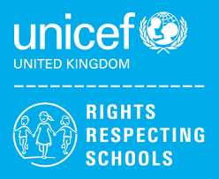 | Rights of the Child | Article 29 (goals of education) Education must develop every child’s personality, talents and abilities to the full. It must encourage the child’s respect for human rights, as well as respect for their parents, their own and other cultures, and the environment.
 | English | Year 12 (U) – AQA Functional Skills English Level 1 & 2 Writing  Year 12 (L) – Edexcel Entry 3 Functional Skills
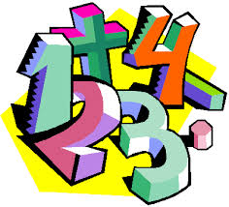 | Maths | Y12 Ascentis Maths Skills Level 1 – Understanding and Using 2D Shapes  Y12 Ascentis Maths Skills Entry 3 - Data Handling – Recording Information, Data Handling – Extracting Information
 | Computing/ICT | Y12/13/14 (L) – WJEC Entry Pathways E3 Certificate – Spreadsheet Software, Database Software, Desktop Publishing Software  Y12/13/14 (H) – WJEC Entry Pathways E3 Certificate – Using Email, Internet Fundamentals  Y12/13/14 (H) - WJEC Entry Pathways Level 1 Award – Word Processing Software, Presentation Software
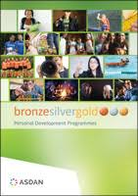 | YAS | Module 1 –Communication; Module 2 – My Community; Module 3 – Sport & Leisure; Module 4 – Independent Living;  Module 6 – Number Handling; Module 7 – Health and Wellbeing; Module 11 – Expressive Arts
 | Employability | Developing Own Interpersonal Skills
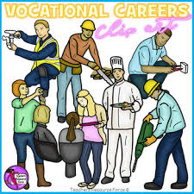 | Vocational Core | Developing a Career Progression Plan
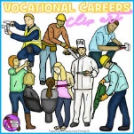 | Vocational Options  Entry 3 / Level 1 | Group 1 – Catering  Group 2 – Volunteering  Group 3 - Gardening
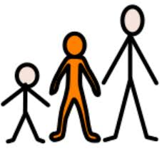 | Preparing for Adulthood | Personal Finance, Independent Living Skills, CEASE training, Peer Pressure, Sex and Relationship education, Drugs, Smoking, Alcohol
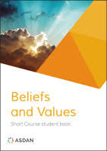 | Beliefs and Values | Peace and Conflict
 | Community Sports | Sports in your community

