YEAR 8 |  | Spring
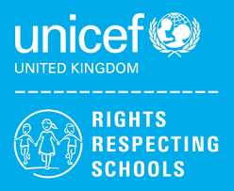 | Rights of the Child | Article 29 (goals of education) Education must develop every child’s personality, talents and abilities to the full. It must encourage the child’s respect for human rights, as well as respect for their parents, their own and other cultures, and the environment.
 | English | 8JF/8MS – A selection of plays & Short stories
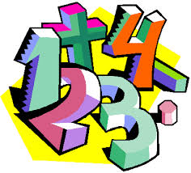 | Maths | 8JF (h) - Decimal Calculations, Angles and Number Properties  8MS – Multiplication & Division, Statistics, Properties of shape, Fractions  8JF (M) – Multiplication & Division, Statistics, Properties of shape, Fractions
 | Science | 8JF Food & Digestion, Plants and their Reproduction, Periodic Table, Metals and their Uses  8MS Food & Digestion, Plants and their Reproduction, Periodic Table, Metals and their Uses
 | Computing/ICT | Just Basic Computer Programming, Desktop Publishing ( Making a Leaflet)
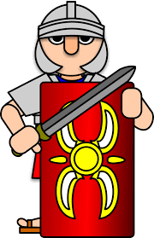 | History | 8 JF/8MS The Transatlantic Slave Trade
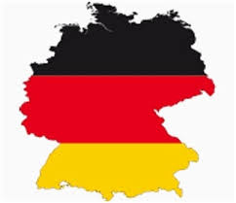 | MFL | German: Body parts
 | Practical Learning | 8JF Healthy lifestyle/Farming  8MS Healthy lifestyle/Farming
 | P.E. | Health Related Fitness, Cricket, Rebound Therapy/Trampolining, Hockey
 | Design Tech | Structures (Bridge Project)  Woodwork – Desk tidy
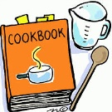 | Food Tech | Mini-Enterprise – Designing and running a Fast Food Outlet
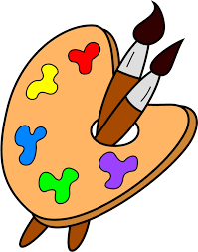 | Art | Stained Glass Windows
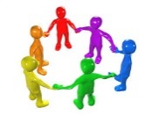 | PHSCE | 8JF/8MS Health and Wellbeing – resilience, emotional well-being, body image  Careers – Careers Advisor, A-Z of Careers
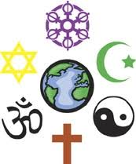 | RE | 8JF Identity and Belonging, How do different people connect with God?
 | Music | Gospel Music
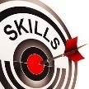 | Skills | 8JF & 8MS Problem Solving

