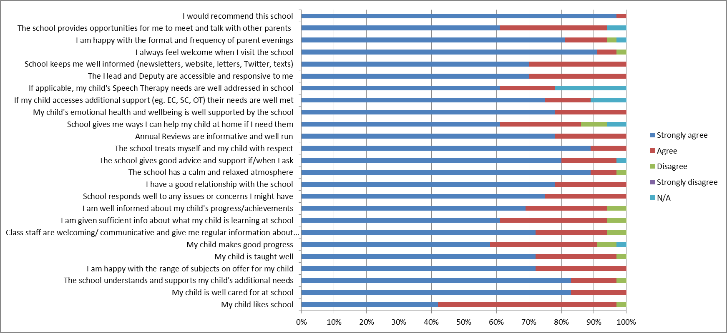

3% typically represents 1 person

36% response overall