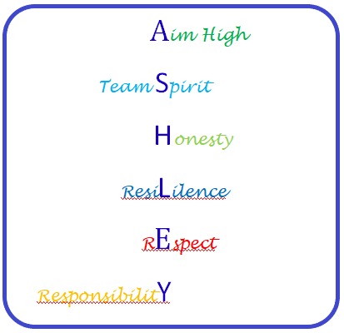**6th Form Behaviour System**

# **Consequences for negative behaviours**

Up to 3 warnings can be given in a lesson.

After 3 warnings you will be taken back to your form tutor

If you get 3 warnings in a lesson, the teacher will phone and let parents know

If you get 3 warnings at break or lunch, whoever is on duty will phone and let parents know

If you receive 10 warnings in a week, you will need to have a ‘reflection’ meeting on Monday morning with a member of staff to discuss how your behaviour can be improved

**Additional consequences for serious behaviours**

Serious behaviours could be fighting, verbal abuse, physical abuse, constant disruptive behaviour, damaging school property etc.

* Off timetable for half a day
* Parents asked to attend a meeting in school
* Behaviour or pastoral support plan
* Fixed term or permanent exclusions

**Each term is a fresh start and warnings are restarted so that you can aim higher each term!**

