**Ashley High School 6th Form**

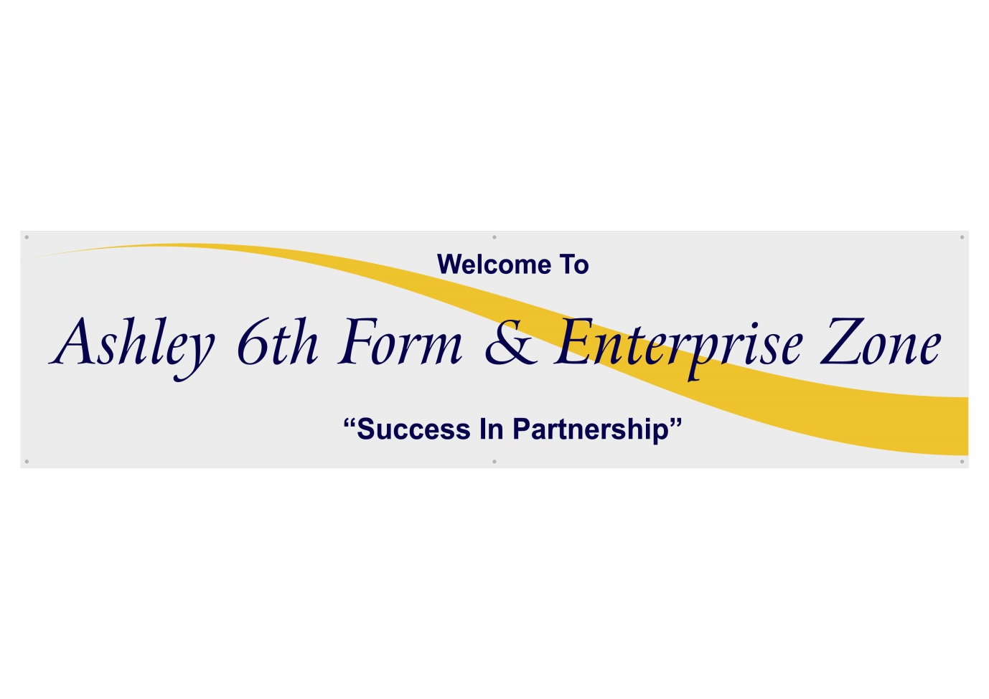**Post-16 Provision for Students with ASC and Social Communication Needs**

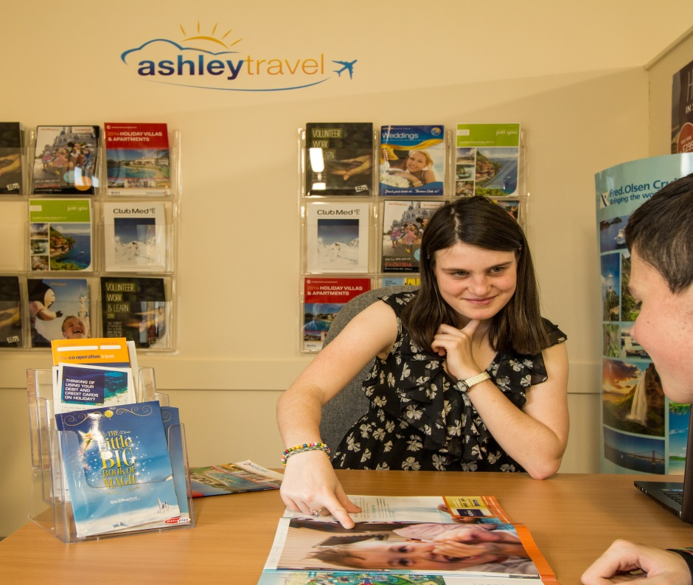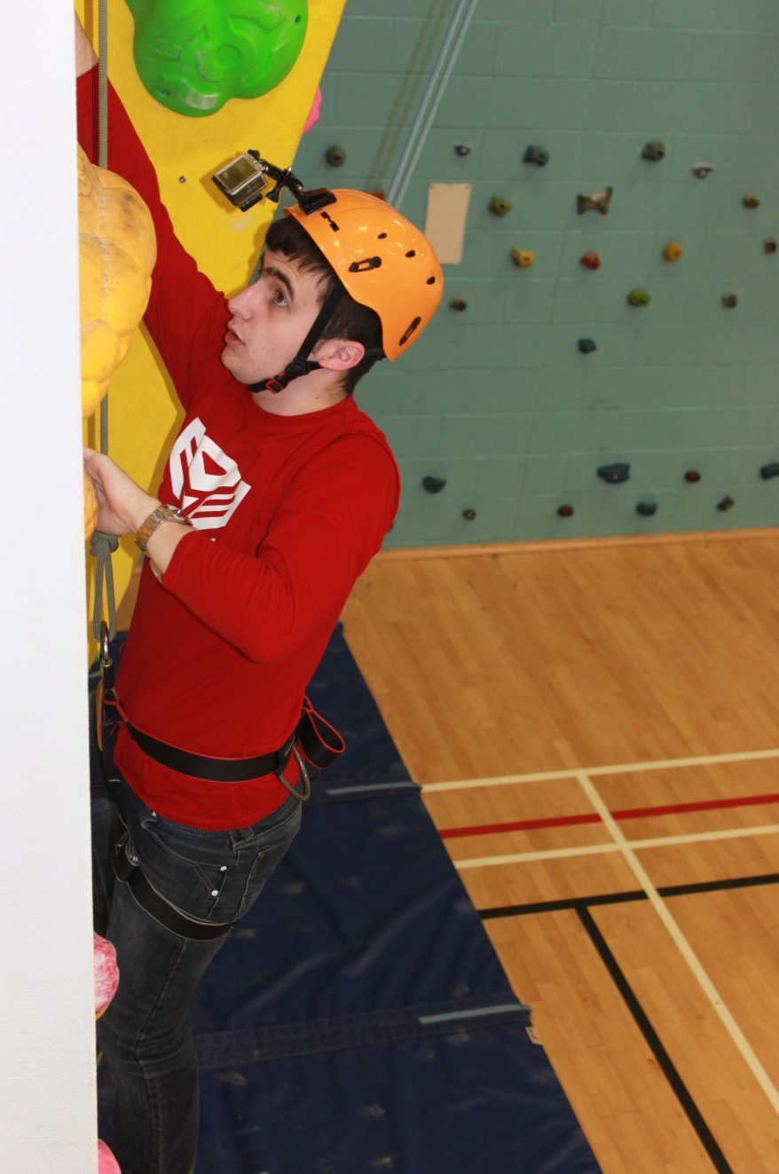

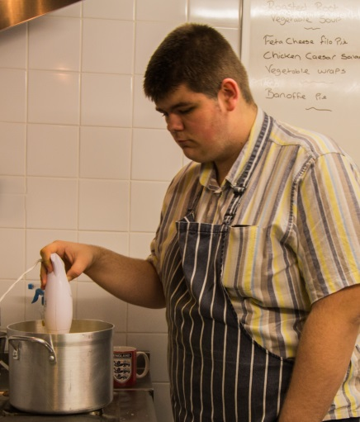

**Why is our 6th Form so special?**

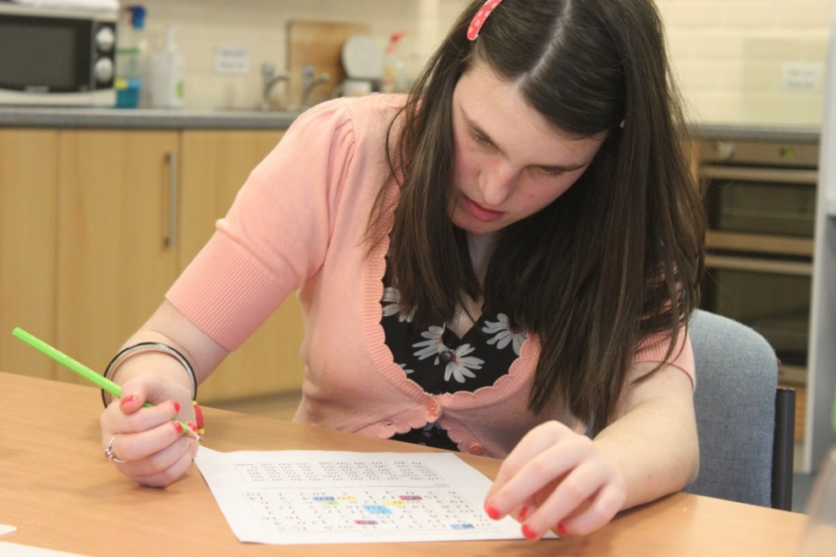

**Our Vision:**

**Ashley 6th Form seeks to provide the highest quality, specialist education for students with an Autistic Spectrum Condition or Social Communication Need, in a positive and supportive environment.**

**Each student studies a core academic curriculum of English, Maths and ICT and a core introductory vocational curriculum, including CoPE/PDP and Employability. All of which runs alongside a programme of study designed to prepare them for adulthood. The specialist curriculum and environment directly address the unique challenges that ASC and SCN bring.**

**Each individual’s programme of study will prepare them for the next step in their independence pathway and adult destination, be it supported accommodation, independent living within the community, further education, training or employment.**

**Our Ethos:**

**The school, in partnership with a range of outside providers and agencies, will deliver rich learning experiences that, in turn, deliver positive outcomes for all students.**

**We are committed to working in partnership with parents/carers and ensuring we provide them with opportunities for communication and support, enabling us to meet the specific needs of each student.**

**The students will be given the skills, understanding and knowledge they need to achieve the highest level of independence. They will be encouraged to explore their own experiences of Autism and Social Communication and develop strategies to manage their condition as part of their development.**

**What makes us *really* special?**

**Our highly-skilled staff offer high-quality teaching with specialist knowledge of high-functioning Autism and Social Communication Needs. Our personalised approach to learning is intended to be both stimulating and enjoyable and is designed to meet the specific needs and aspirations of each student. As a result, they experience enriched learning and outcomes that meet their individual needs in these areas:**

**Language & Communication**

**Literacy Skills**

**Numeracy Skills**

**Social Competence**

**Personal Health & Hygiene**

**Safety Awareness**

**Leisure Activities**

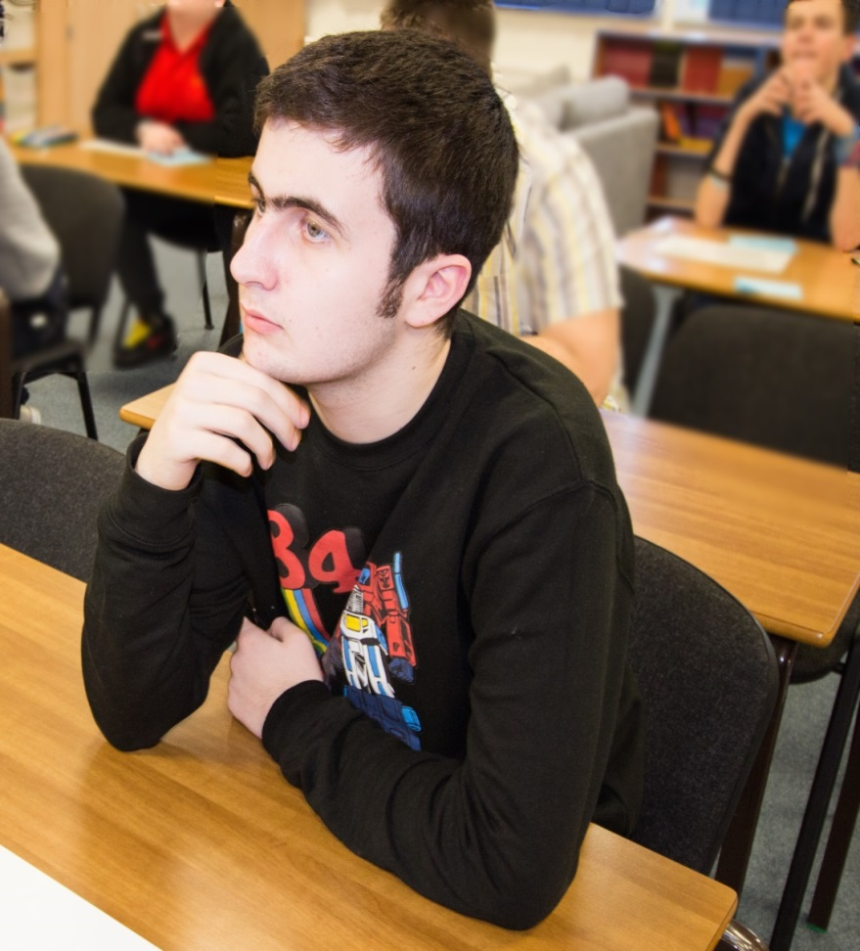**Confidence**

**Rights & Responsibilities**

**Decision Making**

**Problem Solving**

**What is our offer?**

**STUDENT**

**Alongside our Preparing for Adulthood Programme, students study a core academic and vocational curriculum. A range of therapies provide support and promote emotional wellbeing, and regular career planning and review ensures students are able to identify suitable next steps.**

PREPARING FOR ADULTHOOD

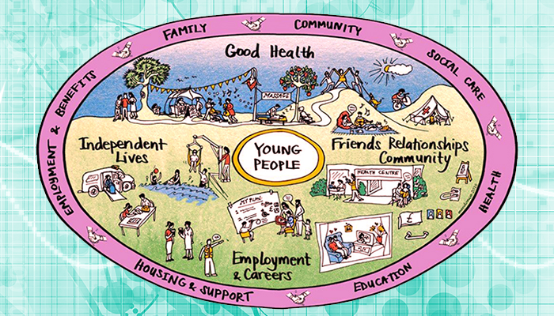**In addition to the academic and vocational aspects of the curriculum, we will give students the skills needed for independence through our ‘Preparing for Adulthood’ programme:**

**Our Preparing for Adulthood programme is at the centre of everything we do. The aim is to equip our students with the essential tools and skills they need to lead a fulfilling adult life. We work closely with other local agencies and professionals to ensure that our students receive the best information and guidance to allow them to make well informed and realistic decisions about their future.**

**Good Health**

**Educating our young people how to take responsibility for and manage their own health and safety needs. They are taught how to manage their own health effectively and made aware of the importance of relationships, choice & consent and staying safe.**

**Independent Lives**

**Developing a wide range of knowledge and skills that will enable our young people to go on and live as independently as possible, from being safe in the home to managing finances to understanding different types of living arrangements and decision making.**

**Friends, Relationships & Community**

**With an emphasis on community participation, students are made aware of the facilities and services available in their local communities and how they can engage positively. Issues such as developing friendships, drugs & alcohol, use of social media, volunteering and knowing where to go for help and support are all addressed.**

**Employment & Careers**

**Students are given the opportunity to build upon the strengths and interests highlighted in their own personal career plans. Through a mix of qualifications, work experience placements, careers adviser interviews, various employer talks and taster sessions, students will explore a range of different career and vocational areas. These include Catering, Business Administration, Retail, Construction, Hairdressing and Motor Vehicle.**

**We work closely with local colleges, training providers and other agencies to ensure students have an effective support network upon leaving the 6th form. College link courses, apprenticeship workshops, independent travel trainers and many support agencies all go towards ensuring a smooth transition into post-19 life, enabling students to reach their full potential.**

**Independent Living**

**At Ashley School we believe in the importance of teaching independent living skills to our students. These skills give them greater control over their lives and offer more choices for the future. They help them to deal with the daily life issues and social demands of living independently. Our independent living approach isn’t about living alone; it’s about being ‘able’ to live alone.**

**Many of our students work on independent skills that include using public transportation, managing a bank account, budgeting, job searching, vocational training and studies that prepare them to pass a driving test.**

**Our young people can go on to have a fulfilling career, meaningful relationships and independence.**

**Wherever possible, real-life opportunities are fully utilised. We are able to give students opportunities to develop Independent living skills in a home environment in our on-site Independent Living Room.**

**Skills include:**

* **Laundry**
* **Personal Finance**
* **Budgeting**
* **Cooking**
* **Personal Hygiene**
* **Shopping**
* **Cleaning**
* **Washing**
* **Ironing**
* **Independent Travel**

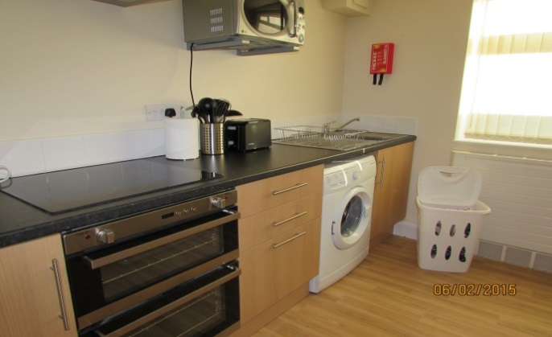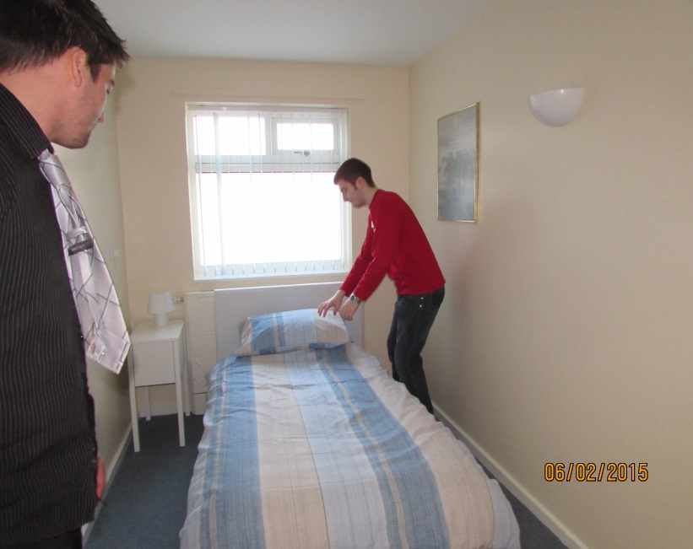



CORE ACADEMIC CURRICULUM

**English**

**Every student is encouraged and aided to achieve their full potential in English, in recognition that literacy and language skills underpin all employability skills.**

**Key Stage 5 English is an extension of skills that students have developed in Key Stage 4 and is personalised for specific needs and past achievements.**

**Literacy skills will be taught in designated Literacy and English lessons, delivered by subject specialists, as an integral part of topic work and within other curriculum areas.**

**Courses that may be offered:**

* **GCSE English Language**
* **English Functional Skills Level 1 and 2**
* **English Functional Skills Entry Level 3**

**Other options may be available dependent on individual students’ aspirations and abilities.**

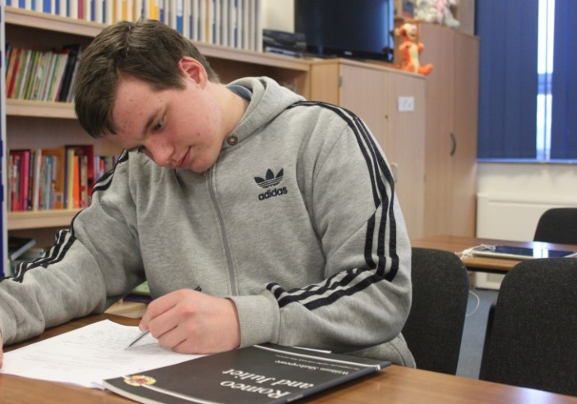

**Maths**

**In our 6th Form students will build on the knowledge and skills already acquired and study an appropriate course for their level of ability.**

**All courses will encourage learners to improve their understanding of Mathematics, its processes and applications, whilst promoting greater understanding and enjoyment in the subject.**

**An important aim of every course will be to build independence skills and the use of mathematical language in everyday life.**

**Courses that may be offered:**

* **GCSE Mathematics**
* **Level 1 Mathematics**
* **Level 1 Managing Personal Finance**
* **Entry Level 3 Mathematics**

**Other options may be available dependent on individual students’ aspirations and abilities.**

**CORE CURRICULUM**

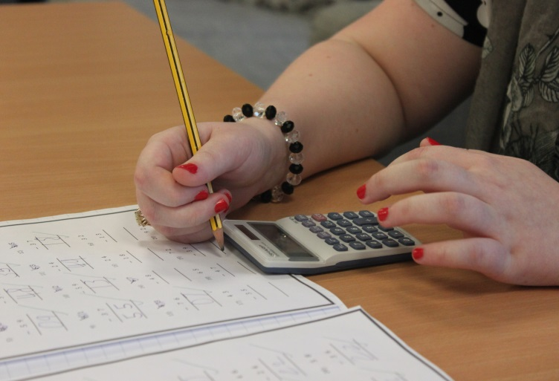

**ICT (Information and Communication Technology)**

**All students at Ashley 6th Form are provided with an excellent ICT experience as a result of the ongoing acquisition of new hardware/software, in line with the latest developments in technology.**

**In Key Stage 5 we aim to build on experiences gained in Key Stage 4, enabling students to further develop their ICT skills and provide opportunities for vocational/work-related learning.**

**The emphasis is on the continued application and practice of ICT in everyday life. Students will become competent ICT learners by being encouraged to solve problems, design and evaluate and gain skills to successfully prepare them for the world of work.**

**Students in Key Stage 5 will have the opportunity to use their existing ICT skills and further develop these by studying one of the courses listed below, specific to students’ ability.**

* **ICT Functional Skills Level 1 and 2**
* **ICT Entry Pathways Entry Level 3**

**Certificate/Award of Personal Effectiveness (CoPE/AoPE) or Personal Development Programme (Bronze, Silver, Gold)**

**The Certificate/Award of Personal Effectiveness is a nationally recognised qualification outcome of the ASDAN programmes. Students who are not quite ready for CoPE, follow a similar programme called the Personal Development Programme. The modules promote a wide range of personal qualities, abilities and achievements of students, as well as introducing them to new activities and challenges.**

**The module titles include:**

* **Communication**
* **Citizenship and Community**
* **Sport and Leisure**
* **Independent Living**
* **The Environment**
* **Vocational and Diploma Preparation**
* **Health and Fitness**
* **Work Related Learning and Enterprise**
* **Science and Technology**
* **International Links**
* **Expressive Arts**
* **Beliefs and Values**

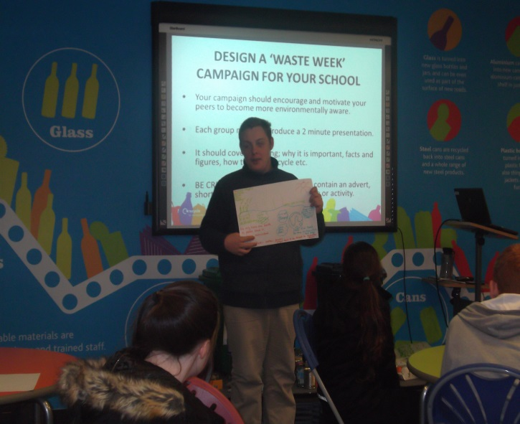

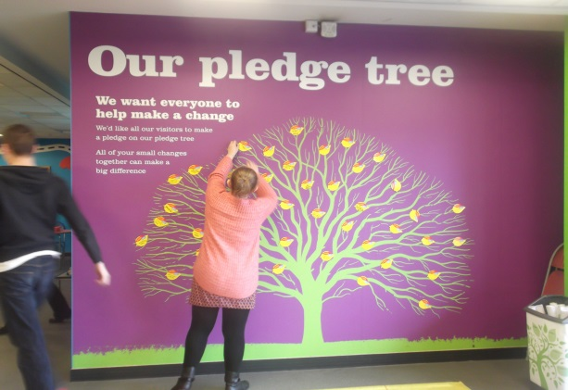

CORE VOCATIONAL CURRICULUM

**Edexcel BTEC Certificate Level 1 Vocational Studies**

**In Year 12 students complete the Pearson BTEC Entry 3 or Level 1 Introductory Certificate in Vocational Studies. This qualification is designed around practical skills and tasks that place an emphasis on learners demonstrating what they can do rather than what they know in theory. The qualification gives learners the opportunity to acquire and develop generic, transferable and sector-specific skills in order to complete tasks and demonstrate a level of achievement that enables them to progress to further learning. The Certificate offers the opportunity for learners to study units from different sectors.**

**Students will study two core units**

* **Being Organised**
* **Developing a Personal Progression Plan**

**Students will also study three units from the following vocational areas:**

* **Business**
* **Digital Media**
* **Hospitality**
* **Land Based Studies**
* **Public Services**
* **Sport**

**In Year 13, students have the opportunity to top up there Vocational Studies qualification to a Diploma and study further core and vocational units or they can choose to attend The Vocational Centre in Runcorn and study for an industry-registered qualification in one of the following areas:**

* **Construction**
* **Hair & Beauty**
* **Painting and Decorating**
* **Motor Vehicle**
* **Catering**

**Employability**

**Ashley 6th Form is committed to developing the skills and attributes that our young people need to gain meaningful employment as they enter adulthood. The Employability program is designed to develop the core skills, qualifications and experience needed to prepare them for a fulfilling life in the workplace. We have strong links with local employers who we work closely with to ensure that work experience is both relevant and rewarding.  We are lucky enough to have a dedicated Careers Leader and Job Coach that works closely with students to help them make key decisions about their future and offer the appropriate level of support as they make the transition into the world of work.**

**In years 12 and 13 students will complete an Open Awards Entry 3/Level 1 Certificate in Skills for Further Learning and Employment. The primary purpose of the qualification is to recognise development of employability skills and/or knowledge. It is designed to either support students with their active search for employment or aid them in their professional development whilst in the workplace. If students decide to continue with us in year 14 they will complete an Open Awards Entry 3/Level 1 Extended Certificate in Skills for Further Learning & Employment.**

**Module titles include -**

* **Developing Own Interpersonal Skills**
* **Health & Safety Awareness**
* **CV Writing**
* **Interview Skills**
* **Customer Service**
* **Preparation for Work**
* **Welcoming Visitors**
* **Making & Receiving Telephone Calls**
* **Work-based Placement**
* **Dealing with Customer Queries and Complaints**

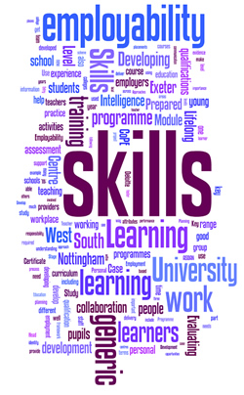

**Work Experience**

**All students at Ashley 6th Form have access to work experience regardless of ability or disability. Students are offered a range of work place situations and a variety of experiences. The work placements encourage the students to develop personal independence and both interpersonal and communication skills. Work experience encourages realistic expectations, socially acceptable behaviour, self-management and problem-solving skills.**

**We try as much as possible to link student’s placements to their interests and aspirations in order to make them a meaningful experience for them. We have developed links with local employers, who are supportive of our students, in areas such as Engineering, Hospitality & Catering, Childcare, Office Administration and Retail.**

**Supported Internships**

**A new study programme for year 13 and year 14 students that takes place over one academic year and is suited to students wishing to enter employment rather than continue in education. At Ashley 6th Form, interns will spend three days per week in the workplace and two days in the 6th Form developing the skills and qualifications needed for work. Each intern will have have the support of the Job Coach to act as the link between the workplace and 6th form. Internships are unpaid but they are all about working towards paid employment via on the job training. A number of students have gained empolyment as a result of the supported internship programme for emplyers such as The Range, Jellybeans Play Centre and Pyramid Distribution.**

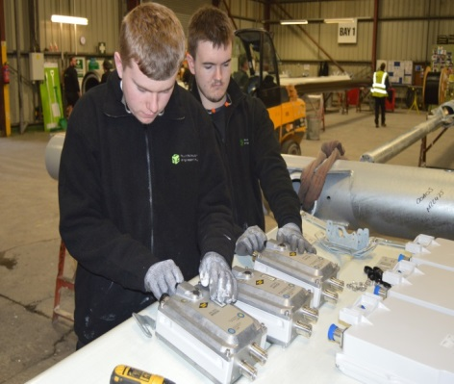

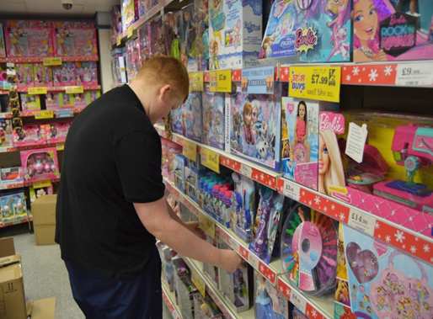

EMOTIONAL WELLBEING

**Speech & Language Therapy**

**We currently employ a Speech & Language Therapy Practitioner and Speech & Language Therapist, who support students with specific communication needs, using innovative and highly motivating strategies to develop functional communication, language and social skills. Sessions are either class-based or 1:1, depending on student’s needs.**

**Occupational Therapy**

**Occupational Therapy aims to develop young people’s independence and functional performance across a wide range of activities and environments. OT assessment and intervention addresses any underlying sensory, perceptual or motor difficulties, which impact upon the young person’s ability to access learning or to engage in activities of daily living. The OT provides assessment, advice, information and evaluation to ensure that each student benefits from the correct sensory, emotional and physical conditions to maximise their learning and well-being.**

**Emotional Support**

**Our Emotional Support staff support identified students with emotional wellbeing on a 1:1 basis. Promoting positive health & wellbeing helps students to understand and express their feelings and build both confidence and resilience. This, in turn, increases their capacity to learn.**

**School Counsellor**

**The counselling service offered by Ashley High School allows students to explore and gain a greater understanding of issues they may be experiencing either in or outside of school. It helps to build confidence and self-esteem in a safe, caring and supportive environment. The counsellor is there to listen and help students see things from a different perspective. The students can speak openly in a non-judgemental setting, where confidentiality is maintained.**

**`**

EXTRA-CURRICULAR

**Independent Travel Training**

**Travel training has proven to be beneficial at Ashley 6th Form, enabling students to have equality of access and independence. It assists in overcoming challenges and removes barriers to independent travel. It empowers students to take greater control in their lives, enabling them to learn new skills and take advantage of opportunities in their communities.**

**Travel training provides tailored and practical help in travelling by public transport, on foot or by bicycle. Travel training aims to help people travel independently and without fear to work, to education, to other key services, or simply for leisure.**

**The benefits of travel training go far beyond the remit of transportation, as the positive impacts are far reaching and lifelong.**

**The benefits to students include:**

* **Increased independence and confidence, and improved self esteem**
* **Increased opportunity to participate in social and leisure activities, and generally broadened horizons**
* **Improvement to general health and well-being, improved quality of life**

**Please be aware that Y13 and Y14 students are often in school half days and so independent travel training is of definite benefit to them.**

**Residential Experiences**

**Students are given the opportunity to experience residential visits in a variety of contexts. They are a powerful vehicle for personal development and for broadening horizons. Visits are undertaken across the year and, at times, during holidays.**

**Previous visits include:**

* **London - Houses of Parliament**
* **DofE Overnight Camps**
* **Canal Boat Trip in the Cheshire Countryside**
* **Visits abroad (past visits include Germany, Belgium and Poland)**

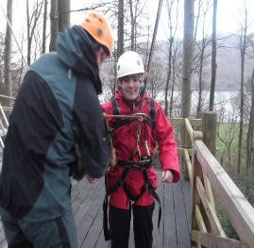

**Duke of Edinburgh Award (D of E)**

**Students have access to this Award at Bronze and Silver level, depending on previous achievements within this prestigious award.**

**Students are required to commit themselves to work within 4 key areas of personal development, all helping to promote essential life-skills and experiences.**

**The 4 key areas:**

* **Expedition**
* **Skills**
* **Physical Activity**
* **Volunteering**

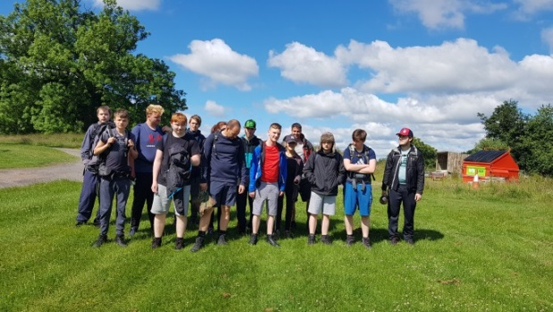

**4-Wheel & 2-Wheel Drive**

**As part of their Y13 ‘Preparing for Adulthood’ programme students will be offered support in applying for and completing the theory part of their driving test and taught basic car maintenance. We can also support them with identifying suitable instruction in driving cars, motorbikes or scooters.**

