ASHLEY HIGH SCHOOL
Emotional Health and Wellbeing Policy

This policy was adopted: June 2017
This policy will be reviewed: June 2019

Lead Teachers: Clare Ogburn, Emma Pearsall (Emotion Coach)

EMOTIONAL HEALTH AND WELLBEING POLICY
Introduction
Emotional health and wellbeing (EHWB) is having the inner strength, resilience and self-esteem to cope with life’s problems and make the most of life’s opportunities. The emotional health and well-being of all members of Ashley High School is fundamental to our philosophy and aims. Our policies and practices are founded in developing and maintaining a happy, healthy school, where all learning can flourish to enable students to become independent, responsible citizens. Our aim is that our students will develop the self-esteem, self- awareness and self-confidence to play an active part in school life and be valued members of their communities, now and throughout their lives.

We believe that emotional health is closely linked to mental health and that as a school we can encourage positive development of mental health in our young people. We believe that students who are mentally healthy will be able to:

• Develop psychologically, emotionally, creatively, intellectually and spiritually
• Initiate, develop and sustain mutually satisfying personal relationships
• Use and enjoy solitude
• Become aware of others and empathise with them
• Socialise and learn together
• Develop a sense of right and wrong
• Face challenges, resolve issues and setbacks and learn from them

The Eight Principles
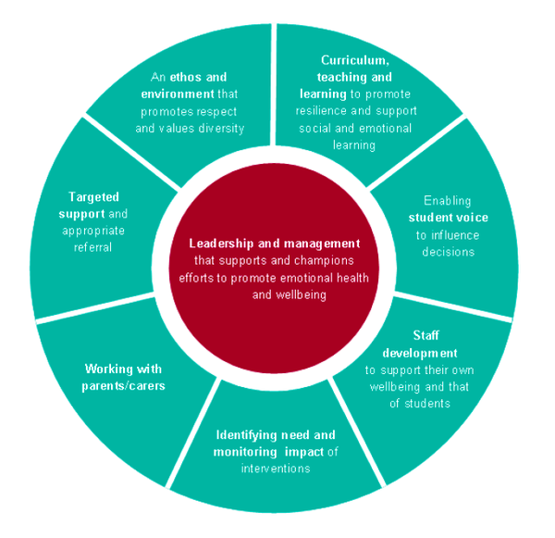
This policy should be read in conjunction with the Gov.uk guidance document ‘ Promoting Children and Young People’s Emotional Health and Wellbeing’ published by Public Health England in conjunction with the Children and Young People’s Mental Health Coalition. At Ashley High we adhere to the Eight Principles outlined in that document. They are:

What does this look like at Ashley High School?
Principle | Practice Examples
Leadership and Management that supports and champions efforts to promote emotional health and wellbeing (EHWB) | - High priority, EHWB included in School Strategic Plan 2016-19  - Performance management targets linked to developing staff expertise in emotional health and wellbeing support  - Strategically planned funding for expert outside providers (eg. Counsellor /Reiki practitioner)  - Funding staff CPD opportunities in order to build capacity (eg. bereavement support, counselling)  - Development of the role of Emotion Coach  - Timetabled sessions given to Emotional Support 1-1  - Funding a School Gym for use by students and staff  - Development of accommodation to include therapy and parent rooms  - Promoting whole school awards (eg. Nurture Award, Healthy Schools)
An Ethos and Environment that promotes respect and values diversity | - Nurture environment across whole school  - Right Respecting School  - Global Learning/International Week/Themed Days
Curriculum, Teaching and Learning to promote resilience and support social and emotional learning | - Core Skills threaded throughout curriculum  - Personal Development weekly lessons linked to the Core Skills (at KS3)  - Weekly PSHCE lessons for all year groups  - Wellbeing Week activities  - Duke of Edinburgh and Mayor’s Award  - Life Skills sessions
Enabling Student Voice to influence decisions | - School Council and Committees  - Speakers School Council Award  - Democracy Awards  - Halton Youth Cabinet involvement  - Make Your Mark, MYP elections  - Q and A with local MP, Mayor of Halton, local councillors  - School Charters (eg. Class, Lunchtime, Playground)  - Speech and Language support sessions
Staff Development to support their own wellbeing and that of students | - CPD opportunities (eg. Massage In Schools Programme, Mindfulness)  - Staff wellbeing opportunities (eg. Reiki, Massage)  - Personal use of School Gym  - Work Life Balance week each term
Identifying Need and Monitoring Impact of interventions | - Evidence of impact case studies  - Accountability measures /Record keeping (eg. SALT sessions)  - Pupil Profiles  - Counsellor reports and recommendations for next steps
Working with Parents and Carers | - Transition meetings, Open door policy  - Training offered (eg. York training)  - Emotion Coach links  - Counsellor sessions offered  - Structured conversations/Pastoral Support Plans agreed jointly  - New Parent room facility
Targeted Support and appropriate  Referral | - Internal referral system for Emotion Coach/Counsellor  - Emotional check-ins  - 1-1 sessions with Emotion Coach/Counsellor  - CAMHS referrals  - EP referrals  - School Nurse
Key policy to be read alongside this document: Counselling in schools: a blueprint for the future (DfE Feb 2016)

