YEAR 7 |  | Autumn
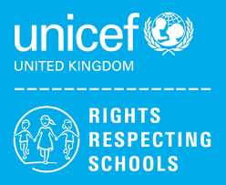 | Rights of the Child | Article 29 (goals of education) Education must develop every child’s personality, talents and abilities to the full. It must encourage the child’s respect for human rights, as well as respect for their parents, their own and other cultures, and the environment.
 | English | Biographies (Boy Roald Dahl)  Autobiographical Writing
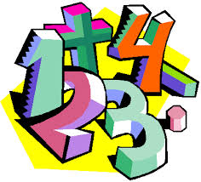 | Maths | 7SA – Place Value, Addition and Subtraction, Geometry (Shape)  7LA – Place Value, Addition and subtraction, Geometry (Shape)
 | Science | Cells and Organisations  States of Matter and Separating Mixtures
 | Computing/ICT | 7SA - Powerpoint Presentations: Endangered Animals,  E-Safety & Cyberbullying  7LA- Powerpoint Presentations: Endangered Animals,  E-Safety & Cyberbullying
 | The Wider World | History – The Romans  Geography- Tectonics  MFL- New Beginnings (Greetings, Feelings and Numbers)
 | Practical Learning | 7LA- Gardening skills, Teambuilding,  Introduction to nature, / Themed  Roahl Dahl Day, Making a sandwich,  Make a hot drink,  Name & address  Practical Numeracy-  Ordering, coin recognition  Practical Literacy and essential skills- Reading instructions speaking and listening
 | P.E. | Basketball / Gymnastics  Badminton / Boccia
 | Design Tech | Plastics - Key Fob  Metals - Coathook
 | Food Tech | Introduction to the kitchen  &  Baking  Health & Safety  Religious Festivals
 | Creative Studies  Art | Elements of Art
 | Creative Studies Music | Pop songs, rhythm
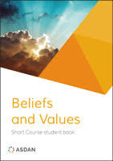 | Beliefs and Values | How to Christians use the Bible?
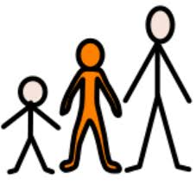 | Preparing for Adulthood | Relationships  Rights and Responsibilities  Ashley Values (Respect, Teamwork, Aiming High…)

