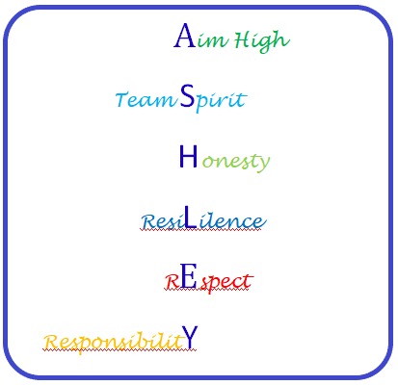
Staff Code of Conduct

Staff, please read this document and sign below
As a member of staff I will –
- Support your child’s wellbeing and safety by providing a safe, supportive
and caring environment
- Communicate in a timely manner about any problems or concerns which are affecting your child’s work or behaviour
- Provide a balanced curriculum tailored to the needs of Ashley High School students
- Promote high standards of behavior, and outline clear expectations in our behaviour policy so we can maintain a safe environment for all children
- Set homework that supports the delivery of the curriculum and provide feedback where appropriate
- Offer opportunities for parents and carers to get involved in school life
- Keep you informed about school matters in general, through the newsletter and your child’s progress in particular through our reporting and communication systems
- All staff will promote the 6 Ashley High School core values of –

- Aim High
- Team Spirit
- Honesty
- Resilience
- Respect
- Responsibility

- AIM HIGH
We will have high expectations of all students and provide relevant challenge in all areas of school life, enabling them to reach their full potential.

- TEAM SPIRIT
We will work collaboratively and enthusiastically with all stakeholders to provide both students and parents/carers with a sense of belonging and positive support. We will celebrate and reward your child’s success.

- HONESTY
We will behave and communicate both openly and transparently, enabling us to develop positive and trusting relationships with all stakeholders.

- RESILIENCE
We will teach and demonstrate strategies that aid students in reacting to, and coping with, situations they find difficult or challenging.

- RESPECT
I will behave and communicate in a kind, appropriate and tolerant manner, making sure we recognise others opinions, needs and viewpoints.

- RESPONSIBILITY
We will act as positive role models and do all we can to provide the holistic care and support your child needs to develop academically, socially, personally and emotionally.

Signed __________________________ (Staff Member) Date _____________________

