11RS -  YEAR 11 |  | Autumn
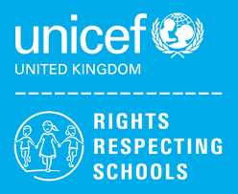 | Rights of the Child | Article 29 (goals of education) Education must develop every child’s personality, talents and abilities to the full. It must encourage the child’s respect for human rights, as well as respect for their parents, their own and other cultures, and the environment.
 | English | 11RS – AQA GCSE English Language Paper 2 – Writer’s viewpoints and opinions  11L – Functional Skills Level 2 Reading/ SUTE Component 1 Hobbies and Interests
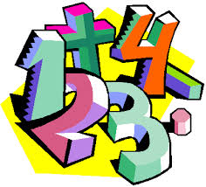 | Maths | 11RS – AQA GCSE (F) - Properties of Polygons, Real Life Graphs, Probability, Volume  11L - WJEC Entry Pathways topics – Measures, Money
 | Science | 11RS – Homeostasis, Inheritance and Evolution / Rate of Chemical Change and Organic Chemistry  11L – Environment, Evolution and Inheritance – Theory and ESA /Environment, Evolution and Inheritance – TDA investigations
 | Computing/ICT | 11RS – EdExcel Functional Skills Level 2 exam preparation  11L – WJEC Entry Pathways Entry 3 Certificate Modules – Spreadsheet Software, Database Software
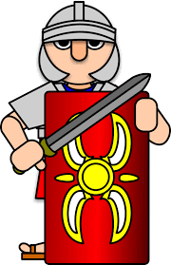 | History | GCSE History- Germany 1890-1945 (Democracy and Dictatorship)
 | Humanities | Climate Change
 | P.E. | Dodgeball  Badminton
 | Duke of Edinburgh | Taking part in individual sports
 | PHSCE | 11L Health & Well Being – Promoting self-esteem and coping with stress. Careers – Decision Making, Self Awareness, Opportunity Awareness.
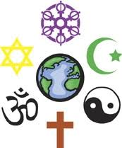 | RE | Where do I belong?
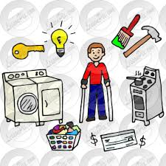 | Independent Living | Looking after yourself and your home / Food and Drink Preparation
 | ASDAN  Construction | Asdan short course – General building operations  Bricklaying
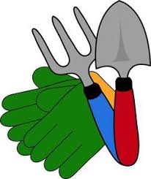 | ASDAN  Gardening | Asdan – Short Course – Plants & Planting
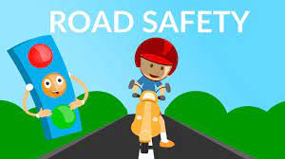 | Travelling Independently | Crossing roads safely and independently / Preparing yourself for a journey using public transport

