

**GET YOUR CHILD TO SCHOOL ON TIME**

**their future is in your hands….**



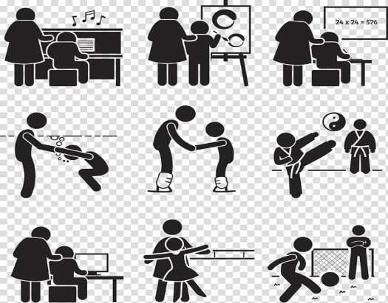

**There is a proven link between good school attendance and high level attainment and development.**

**Regardless of the reason, if your child is absent from school it will impact on their learning and development.**

**Parents/Carers are legally responsible for ensuring their child attends school on time every day.**

There are **190** days in a school year, which leaves **175** days to spend on family time, time with friends, holidays, appointments, and other things

|  |  |  |  |  |
| --- | --- | --- | --- | --- |
| **190 days in school**  **= 100%**    **Very best chance of success** | **Only 183 days in school**  **= 95%**    **Excellent chance of success** | **Only 179 days in school**  **= 94%**    **Less chance of success** | **Only 175 days in school**  **= 92%**    **Harder to make progress** | **Less than 173 days in school**  **= less than 90%**  **Persistent absentee – definite negative impact** |

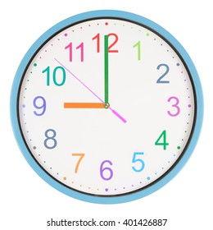**For more information on supporting your child’s attendance, and your legal responsibilities as a parent/carer, including fines, please visit -**

**Unauthorised leave in term time**

**Children are not entitled to holidays in term time. Family holidays should be taken during school holiday periods. ‘Leave of Absence’ requests forms are available from the school office to request leave due to exceptional circumstances. Holidays do not constitute exceptional circumstances and will not be considered! Leave of Absence forms must be completed and returned to the Head Teacher, who will consider the request. Fines of £80, or even £160 per parent/carer may be issued by the local authority where unauthorised leave has been taken during term time.**

**What is a Fixed Penalty Notice?**

**The Anti-Social Behaviour Act 2003 introduced legislation for local authorities to issue Fixed Penalty Notice Fines to parents/carers of pupils who have unauthorised absences from school. A Fixed Penalty Notice Fine can be issued for 2 reasons:**

**· If a holiday is taken during term time without the permission of the Head Teacher**

**· If a pupil has unauthorised absence from school and their parent/carer fails to co-operate with school staff and/or other professionals to address the situation.**

**Your Legal Responsibility**

**If your child does not attend school regularly (over 90%), after appropriate support is offered, the local authority can take action against you. This can be through a Fixed Penalty Notice (fine), an Education Supervision Order or prosecution.**

**Too ill to attend school?**

**Children can attend school with minor ailments like toothache, headache, stomach ache, cold, sore throat, etc. Over the counter medicines can be given before school. School will contact you if they become too ill to remain in school. Children should stay off school for 48 hours if they are vomiting or have diarrhoea.**

**If you are unsure how long your child should be absent with an illness, speak to the school, your doctor or your pharmacist for advice.**

**Punctuality**

**It is important that your child attends school every day and on time. Arriving late to school is unsettling for children and their routines, often causing much anxiety.**

**DID YOU KNOW………….?**

**10 minutes late every day = 32 hours learning lost each year!**

**Persistent Absence**

**Any child with attendance below 90%, regardless of the reason for absence, is considered to be a ‘persistent non-attender’. This equates to just 2 days absence each month.**

**IS YOUR CHILD A ‘PERSISTENT NON-ATTENDER’?**

**Statistics show that ‘persistent non-attenders’ are less likely to achieve their full potential, and such absence can affect a child’s personal development and future prospects.**

**Absence during term time**

**Children must not be absent from school for:**

* **Day trips**
* **Shopping**
* **Birthdays**
* **Parent/carer or sibling illness**
* **Tiredness**

**Medical Appointments**

**Where possible, all appointments should be booked outside of school hours. Where this is not possible, the amount of school time missed must be kept to a minimum. School will not authorise the time off unless medical evidence is provided.**

**https://www.childrenscommissioner.gov.uk/back-into-school/resources-for-families/**

**and**

**https://educationhub.blog.gov.uk/2024/08/19/fines-for-parents-for-taking-children-out-of-school-what-you-need-to-know/**