HAF EASTER TIMETABLE

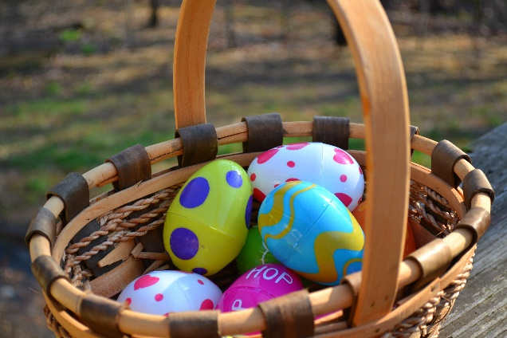

For all enquiries and to book a place please email [HAFatCHI@hotmail.com](mailto:HAFatCHI@hotmail.com)

|  |  |  |  |
| --- | --- | --- | --- |
| **DATE** | **ACTIVITY** | **NON-SEND SESSION** | **SEND ONLY SESSION** |
| **Thurs 6th April** | **FOREST SCHOOL with CAMP CURIOSITY** | **10.00-12.00 (S)** | **12.30-2.00 (SS)** |
| **Fri 7TH April** | **CREEPY CRAWLIES & REPTILES with ANIMAL TEACH** | **10.00-12.00**  **(S)** | **12.30-2.00**  **(SS)** |
| **Sat 8th April** | **EASTER EGG HUNT** | **10.00 start**  **(F)** | **THROUGHOUT DAY** |
| **Sun 16th April** | **CREEPY CRAWLIES & REPTILES with ANIMAL TEACH** | **12.00-1.30**  **(S)** | **1.45-3.00**  **(SS)** |

