YEAR 14 |  | Autumn
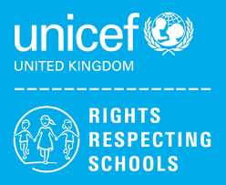 | Rights of the Child | Article 29 (goals of education) Education must develop every child’s personality, talents and abilities to the full. It must encourage the child’s respect for human rights, as well as respect for their parents, their own and other cultures, and the environment.
 | English | 6th Form (U) – Functional Skills Level 2 – Spoken Language Skills & Reading Skills  6th Form (L) - Functional Skills Level 1 – Spoken Language Skills & Reading Skills
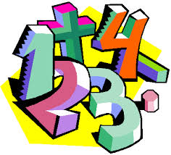 | Maths | Level 1 – Maths skills qualification – a selection of modules including Handling Data  Entry 3 – Ascentis Maths skills qualification – a selection of modules including addition & subtractions skills, multiplying whole numbers
 | Employability  Level 1 | Award - Developing Own Interpersonal Skills  Certificate/Extended Certificate – Health, Safety and First Aid
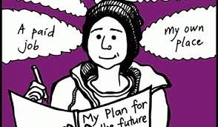 | Preparing for Adulthood | Independent Living  Budgeting

