Safeguarding

**‘Everyone has the right to feel safe’**

# What is Our Safeguarding Policy about?

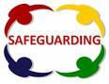All of the adults around you think that your health, safety and welfare are very important.



In our school we:

* 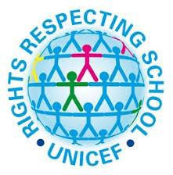respect everyone
* help to protect you and your rights
* do our best to help everyone make good progress and reach their potential
* teach you how to recognise risks in different situations
* teach you to protect yourselves and stay safe

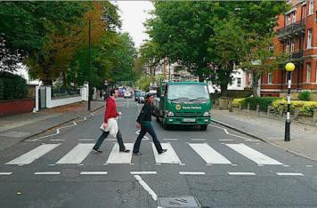

# How are you protected at Ashley High School?



* We provide a safe environment for everyone to learn
* We help to ensure that you remain safe, at home as well as in school
* We think it is important for everyone to know where to get help if they are worried or unhappy about something.

**‘Everyone has the right to say what they think and have their views listened to’.**

# If you need to talk – we will listen

You can talk to:

* + any adult in school
  + staff in your class
  + Mrs Pearsall, Mrs Kirwan or Alma

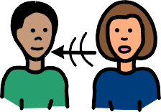 **Tell a member of staff if someone is:**

* + - Bullying you
    - Saying things that you do not, like or

upsets you

* Touching you where they shouldn’t
* Hitting you or hurting you
* Sending unkind messages or photos on the internet or to your phone
* Making you feel uncomfortable



Also remember

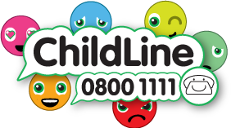

There for whenever you need to talk