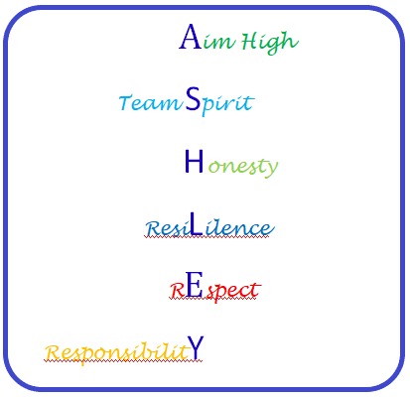
Parent/Carer Code of Conduct

Parents/Carers, please read this document and sign below
As a parents/carers we will –
- Ensure that our child attends school regularly, on time, properly equipped and in correct school uniform
- Attend any relevant meetings or school appointments in order to achieve the best outcomes for our child
- Read and stay up to date with the school’s policies and information
- Treat all members of the school community with care and respect (including social media communications)
- Read any communications sent home by the school and respond promptly where necessary
- Support the 6 Ashley High School core values of -

- Aim High
- Team Spirit
- Honesty
- Resilience
- Respect
- Responsibility

- AIM HIGH
We will promote our child’s development and education by encouraging them to have a positive work ethic and supporting them to complete all homework tasks, enabling them to reach their full potential.

- TEAM SPIRIT
We will work in partnership with the school to celebrate and reward our child’s achievements and support them as needed.

- HONESTY
We will communicate openly and clearly with school staff in order to best support our child’s needs.

- RESILIENCE
We will focus on the positive elements of students school life, helping our child to become more resilient and to cope with difficult or new learning experiences appropriately.

- RESPECT
We will behave and communicate in a kind, appropriate and tolerant manner, making sure we recognise others opinions, needs and viewpoints.

- RESPONSIBILITY
We will act as positive role models to our child, ensuring they are aware of, and observe the 6 Ashley High School core values.

Childs Name ________________
Signed __________________________ (Parent/Carer) Date _____________________

