YEAR 10 |  | Autumn
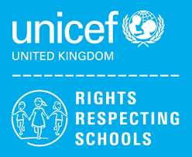 | Rights of the Child | Article 29 (goals of education) Education must develop every child’s personality, talents and abilities to the full. It must encourage the child’s respect for human rights, as well as respect for their parents, their own and other cultures, and the environment.
 | English | 10GG - Speaking and Listening  10AK – Step up to English Component 1 - Pets
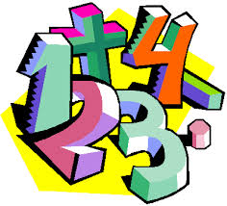 | Maths | 10AK - Place Value, Addition & Subtraction, Multiplication & Division, Fractions – working towards WJEC Entry Pathways Maths qualification  10GG - Rounding, Pythagoras, 2D Representation of 3D Shapes, Standard Form, calculating with Percentages – working towards GCSE (F)
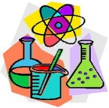 | Science | 10AK - The Human Body – Theory and ESA / The Human Body – TDA investigations  10GG - Cell Biology and Organisation / Atomic Structure, Periodic Table and Bonding and Structures
 | Computing/ICT | 10AK – WJEC Entry Pathways Entry 3 Certificate modules – Word Processing, Presentation Software  10GG – WJEC Entry Pathways Level 1 Certificate modules – Word Processing, Presentation Software
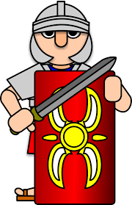 | History | GCSE History- Conflict and Tension (The Inter War Years 1919-1939)
 | Humanities | Tectonic events
 | P.E. | Dodgeball / Basketball
 | Food Tech | Home Cooking Skills  BTEC Level 2  Planning a two course meal & Methods of cookery
 | Creative Media | WJEC – Entry Level Pathways- Ceramics Art Project
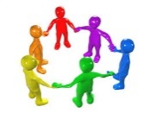 | PHSCE | 10GG – Health & Well Being – Mental Health, Tackling Stigma, Building Resilience. RSE – The benefits of self-examination and screening.
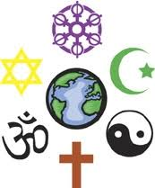 | RE | 10AK- What do we mean by religion and world views? (contentious issues)  Judaism - How do Jewish holy days remind adherents of their faith?
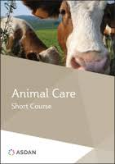 | Animal Care | Animal Investigations
 | Preparation for work | Health & Safety
 | Duke of Edinburgh | Taking part in team sports

