YEAR 14 |  | Spring
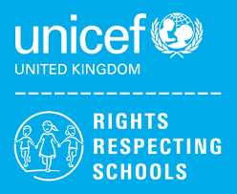 | Rights of the Child | Article 29 (goals of education) Education must develop every child’s personality, talents and abilities to the full. It must encourage the child’s respect for human rights, as well as respect for their parents, their own and other cultures, and the environment.
 | English | (Lower) Functional Skills Level 1 – Reading &Writing Skills  (Upper) Functional Skills Level 2 - Reading
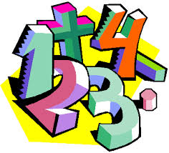 | Maths | Level 1 Maths Skills - Measure: Time & Temperature  Entry 3 Maths skills – Measures – distance and length
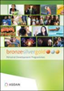 | CoPE/YAS | Developing and demonstrating a range of personal skills by completing a choice of modules from the following:  Communication; Citizenship and Community; Sport and Leisure; Independent Living; The Environment; Vocational Preparation; Health and Fitness; Work Related Learning and Enterprise; Science and Technology; International Links; Expressive Arts; Beliefs and Values (RE)
 | Employability  Level 1 | Preparation for Work
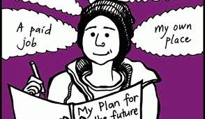 | Preparing for Adulthood | Work experience, Traveling Independently

