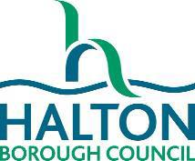

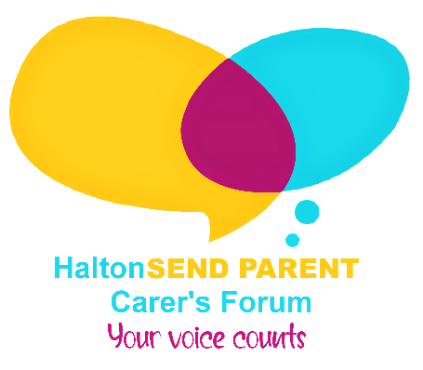
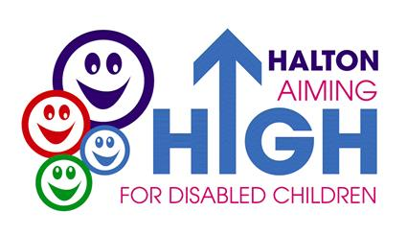

Halton’s
Short Breaks Services Guide 2026

A – Z of Services by Provider Name

Provider |  | Type | Description of Service | Who is it for?
Halton Carers Centre Runcorn   |  | Carers Centre support | Support and information for carers including training, therapy and advice on issues relating to the caring role. Carers Forum and support for Halton Impart. Organise trips out and family events. Provide support and activities for young carers living in Halton | All carers of disabled children
Halton Borough Council  Children & Families Service – Inglefield |  | Overnight Residential Breaks | Provides overnight breaks for those children who have complex needs. | Children aged 4-18 years.  Following a Social Work assessment
Halton Borough Council – Family Hubs  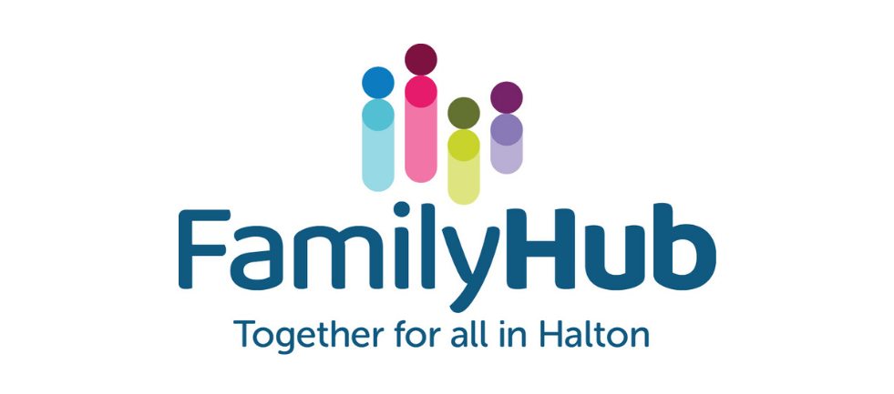 |  | Family Hub Activities | Range of services for children and family group including activity groups, parenting support and fun events. Various locations throughout Halton. | Children and their families can attend many events
Halton Borough Council – Short Breaks Service for Children with Disabilities |  | Family Events | Events organised in school holidays so that families can join in and have fun together and meet other families. These activities are very popular so you need to book with the team to ensure you get a place. Various locations throughout Halton. | All family members where they have at least one child who has a disability
Halton Borough Council – Short Breaks Service for Children with Disabilities |  | Personal Budget/ Direct Payment  Agency Contract | Only available following an individual assessment of the child’s needs and must deliver the outcomes for the child as identified in their individual plan. | Children aged 0-18 years who have additional needs/disability.  Following  Short Break Assessment
(Alternative to Short Breaks Service for Children with Disabilities package) |  |  | Two types of budget available:  Community Activity budget  Families can use to purchase activities in the community for your child to access.  Individual Support budget  Families can use to employ a Personal Assistant to support your child either in the home or outside in the community. | Children aged 0-18 years who have additional needs/disability.  Following  Short Break Assessment
Halton Play Council  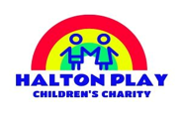 | Short Breaks Weekend Play Activities |  | Weekly Saturday sessions running for 50 weeks of the year at:  - Glendale Family Centre Runcorn  - Halton Lodge Children’s Centre Runcorn  - Warrington Road Children’s Centre, Widnes | Children aged 4 to 8 years and 8 to 18 years old eligible for short breaks  Referrals through Short Breaks Service for Children with Disabilities
Halton Play Council | Short Breaks Inclusive Play Schemes |  | Inclusive Play Schemes delivered during 2 weeks of the summer school holidays.  These are inclusive but have allocated sessions for disabled children with additional support provided for those who are assessed as needing it.  Various locations throughout Halton. | Children and young people aged 5 to 12 years eligible for short breaks  Referrals through Short Breaks Service for Children with Disabilities
Halton Play Council | Toy Library |  | Provides a wide range of toys and resources that families or groups can loan.  This includes larger toys, sensory activities and specialist equipment. Play Resource Centre, Mersey Road, Runcorn. | Families or activity groups  Self-referral
Everton in the Community   | Short Breaks School Holiday Activities, Trips and Visits |  | Activities include: Barnstondale Activity Centre, Inflata Nation, Everton Youth Club, Bowling and a range of other community activities.  Various locations in Halton and the wider region.  Maximum Cost - £3 per child | Children and young people age 7-17 years eligible for short breaks.  Self-referral
Mako Create   | Short Breaks Creative digital art, media and tech focused activities |  | Monthly 2 hour long workshops. Various venues including The Studio Widnes and Halton Lea Library, Runcorn. | Children and young people aged 8-17 years eligible for short breaks  Self-referral
Sean Bailey Wellness   | Short Breaks Multi-skills activities |  | Term-time multi-skills activities  Sandymoor Ormiston Academy | Children and young people aged 4-14 years eligible for short breaks  Self-referral
Turtle Tots   | Short Breaks Splash Play |  | Term time water based play activities  Chesnut Lodge School | Children and young people aged 4-17 years eligible for short breaks.  Self-referral
Turtle Tots | Short Breaks Swimming Lessons  Each lesson can accommodate 6 children per lesson with 1:1 in pool support |  | Term-time Swimming Lessons with a Teacher and in-pool 1:1 Assistant. Cost £7.50 per lesson paid by monthly direct debit to Turtle Tots. | Children aged 4-11 years eligible for short breaks.  Self-referral
Vibe   | Vibe Outdoor Activities |  | Monthly outdoor focused activity sessions, shaped by young people. Activities typically include - canoeing, rock climbing, archery, den building, orienteering, and cycling.  Delivered as a 3 hour ‘junior Club’ in the morning and a 3 hour ‘Youth Club’ in the afternoon typically on a Saturday with transport included from identified collection points. | Ages:  Junior Club:  8 to 11 years eligible for short breaks.  Youth Club:  12 to 17 years eligible for short breaks.  Self-referral
Vibe | Short Breaks Vibe Outdoors - Group Activities for young people |  | Activity and friendship groups for young people in Halton.  Fortnightly weekend sessions running in Widnes and Runcorn with additional sessions during the holidays.  Young people will have the opportunity to participate in a range of activities and to work towards achieving a Prince’s Trust Achieve Award and/or a Lord Derby Award. | Children and young people aged 12-18 years eligible for short breaks.  Referrals through Short Breaks Service for Children with Disabilities
Positive Future Consultancy Ltd  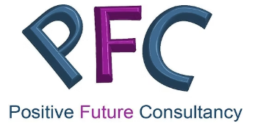 | Personal Assistant Recruitment Service |  | Support to assist families to recruitment a personal assistant where the need has been identified in a short breaks plan. | Children up to and including 17 years old following a short break assessment  Referrals through Short Breaks Service for Children with Disabilities

