YEAR 8 |  | Autumn | Spring | Summer
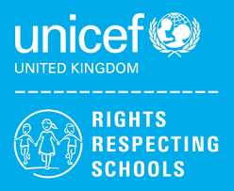 | Rights of the Child | Article 29 (goals of education) Education must develop every child’s personality, talents and abilities to the full. It must encourage the child’s respect for human rights, as well as respect for their parents, their own and other cultures, and the environment. | Article 29 (goals of education) Education must develop every child’s personality, talents and abilities to the full. It must encourage the child’s respect for human rights, as well as respect for their parents, their own and other cultures, and the environment. | Article 29 (goals of education) Education must develop every child’s personality, talents and abilities to the full. It must encourage the child’s respect for human rights, as well as respect for their parents, their own and other cultures, and the environment.
 | English | Other Cultures – Stories  Other Cultures - Poetry | Modern Play/Drama – Our Day Out/Blood Brothers | Travel Writing – Non-Fiction Texts  (Emails & Letters, Brochures & Adverts, Reviews)  Speaking & Listening
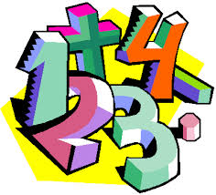 | Maths | Place Value  Addition & Subtraction  Shape | Money  Multiplication & Division  Length & Height  Mass, Capacity & Temperature | Fractions  Time  Statistics  Position & Direction
 | Science | Health and Human Body  Chemical Reactions | Electricity and Magnetism  Respiration and Photosynthesis | Earth’s Atmosphere  Space
 | Computing/ICT | After School Club – Creating a Survey / Gathering Information  Powerpoint Presentations | JustBasic Computer Programming  Desktop Publishing | Spreadsheet Modelling  Data Handling
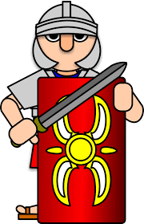 | The Wider World | Industry  Industrial Revolution  Economics  Recap core language, rooms in a school, classroom objects  Industry  Industrial Revolution  Economics  Family Members, personal info | Development  Health and Medicine  World Development  Face parts, describing with colours  Development  Health and Medicine  World Development  Face and body parts, nouns and commands | Developing Continents  Transatlantic Slave Trade  Kenya  Role play, animal nouns, adjectives  Developing Continents  Transatlantic Slave Trade  Kenya  Weather phrases, seasons
 | Practical Learning | Managing my Money  How much do things cost?  Luxury or Necessity  Shopping Essentials  Price Comparisons  Visit to Local Shops  Visit to Supermarket  (Comparing Prices)  LOTC – Local Area  Library Visit  Kingsway Leisure Centre  Victoria Park/Coffee Shop  Widnes Town Centre  Shopping City Runcorn  Dr’s/Chemist  The Hive | Gardening  Planting in the Garden  Using Produce  Wildlife in the Garden  Art in the Garden  Hough Green Station  Community Project  Wonky Gardens  Global Learning  Fair Trade Fortnight  World Wildlife Day  British Science Week  International Day for Elimination of Racial Discrimination | Forest School
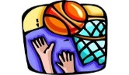 | P.E. | Basketball  Orienteering  Dodgeball  Badminton | Health Related Fitness  Trampolining  Hockey  Cricket | Rounders  Athletics  Walking  Cycling
 | Design Tech | Health & Safety  Structures (8MS)  Desk Tidy (8MS) | Mechanisms (Levers) (8MS)  Health & Safety  Structures (8CB) | Desk Tidy (8CB)  Mechanisms (Levers) (8CB)
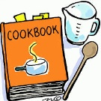 | Food Tech | Designing a Food Outlet & Mini – Enterprise (8CB)  Mini-Enterprise & Healthy Living (8CB) | Healthy Living & Health and Safety (8CB)  Mini-Enterprise & Designing a Food Outlet (8MS) | Healthy Living & Health and Safety (8MS)
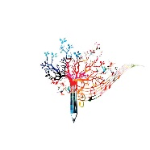 | Creative Studies  Art | Mixed Media  Stained Glass Windows | Gustav Klimt | Collage  Eric Carle Minibeasts
 | Creative Studies Music | Pop/Soul Music  Ukulele Practical | Gospel Songs  Keyboard Practical | Improvising  Classical Music
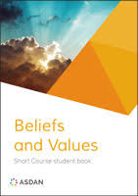 | Beliefs and Values | Christianity(God)  Why is it sometimes difficult to do the right thing?  Islam  Why is the Qur’an so important to Muslims? | Hindu Dharma  What might Hindus learn from stories about Krishna?  Christianity (Jesus)  What do we mean by a miracle? | Christianity (Church)  How do people decide what to believe?  Judaism  Do people need laws to guide them?
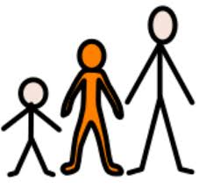 | Preparing for Adulthood | Good Health  Alcohol and drug misuse and managing peer influence  Community Inclusion  The law and legal and illegal substances  Rights and Responsibilities in the Community  Independent Living  Household Cleaning  Transport – Buses/Directions | Community Inclusion  Strategies for safely challenging stereotyping, prejudice, bigotry, bullying and discrimination  Good Health  Mental Health and Resilience, Emotional Wellbeing including Body Image  Independent Living  Common Ailments/Medical Appointments  Employment/Careers  Introduction to the Careers Advisor and the A-Z of Careers  Skills and Qualities  Community Inclusion  British Law and Cultural and Religious Expectations and Practices | Good Health  Managing Change and Loss  Community Inclusion  My own Core Values  Tackling Age and Disability Discrimination  Independent Living  Knowledge of Community Resources/Emergency and Safety Skills  Employment/Careers  Careers Lessons/STEM Talk  Community Inclusion  All individuals have the same rights and opportunities in education and the workplace

